COVID Activities (with picture)

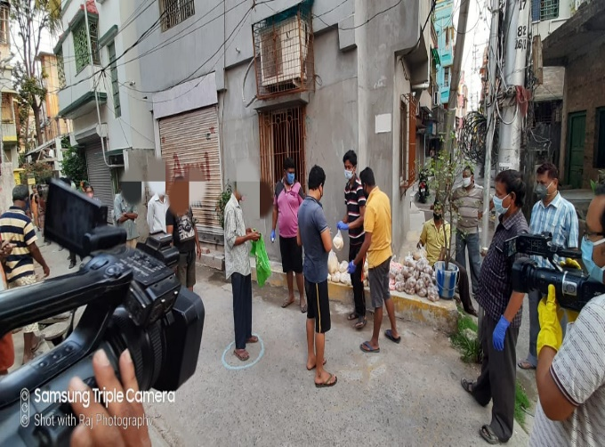
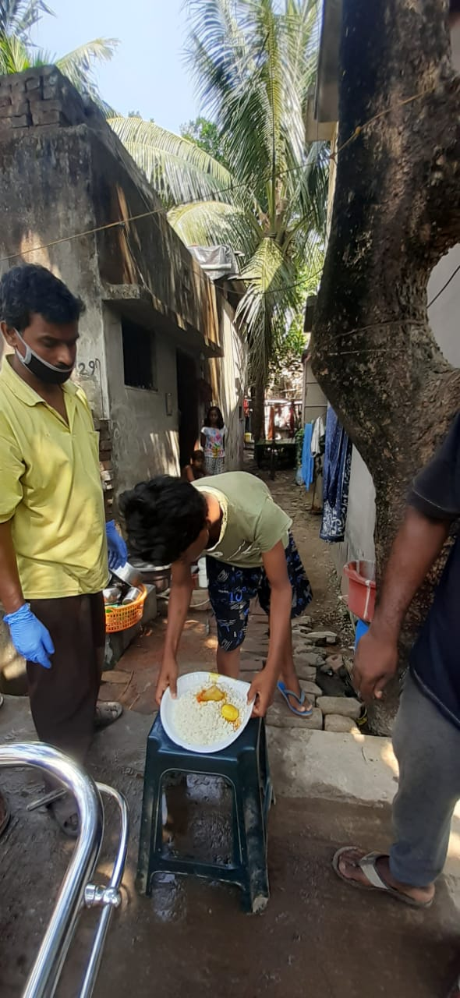
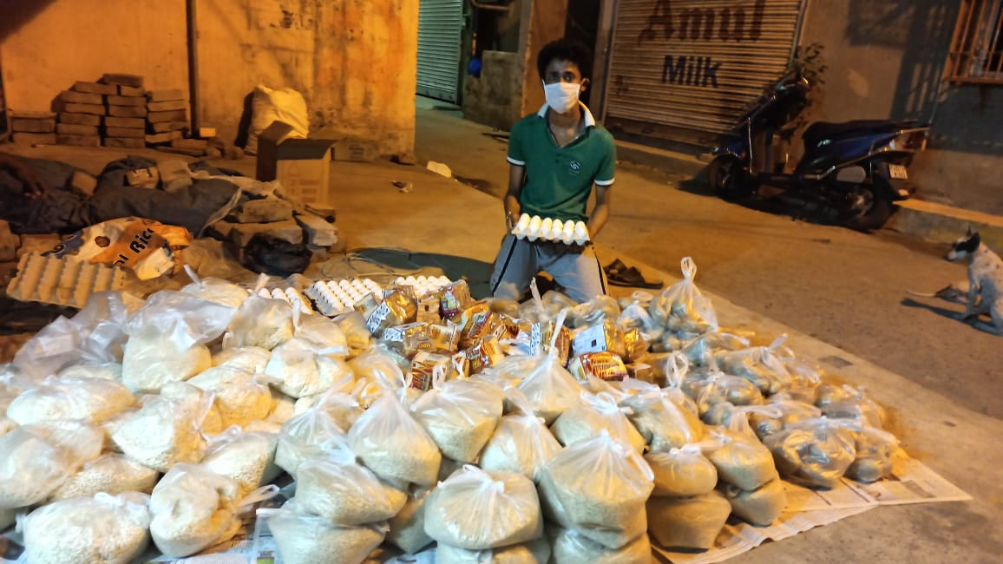
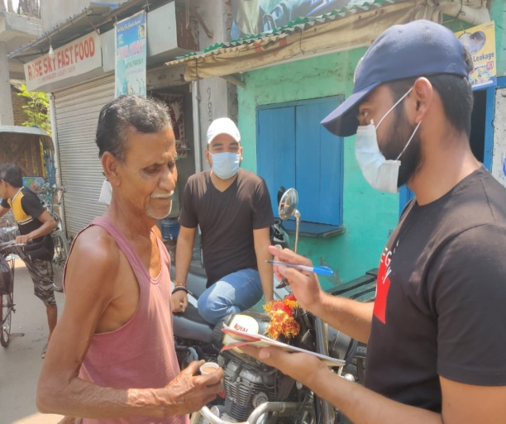
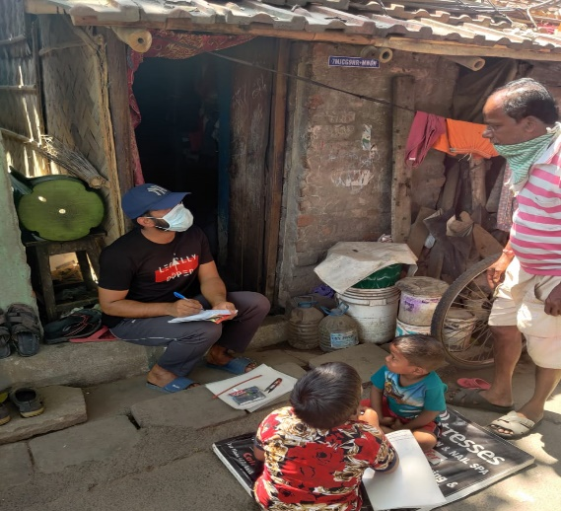
Students of GNIT from all the depts including ECE visited to “Sangbedan” , a special child care home in Shyambazaar, to celebrate Poila baishakh(Bangla New Year) on 15th April 2021. This drive was initiated by PRAGAATI , a social welfare group founded by Alumni ,Faculty and students of GNIT
