Dept. of Food Technology
Alumni activity
Academic year: 2020-2021
- Alumni talk on “Prospects in Food Technology” by one distinguished alumni Mr. Kiranmoni Debnath, Food Safety Officer (WBGS), Department of Health and Family Welfare, Govt. of West Bengal 19th July, 2020.
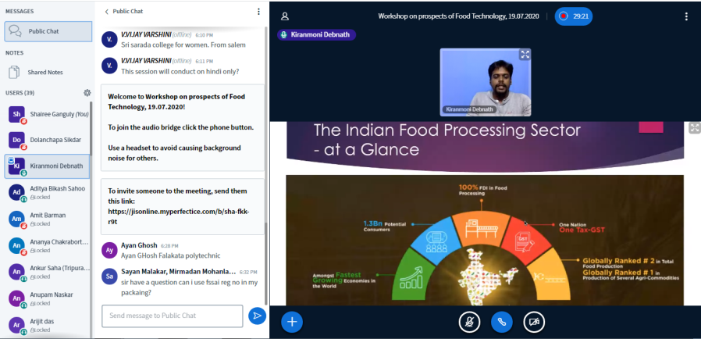

Academic year: 2019-2020

- Industry Mentor Meet: Webinar on “Food Safety & Quality Assurance” by distinguished alumni of Dept. of Food Technology, Mr. Debjit Ghosh, Food Safety Manager, MILEI GmbH of Moringa Group, Germany
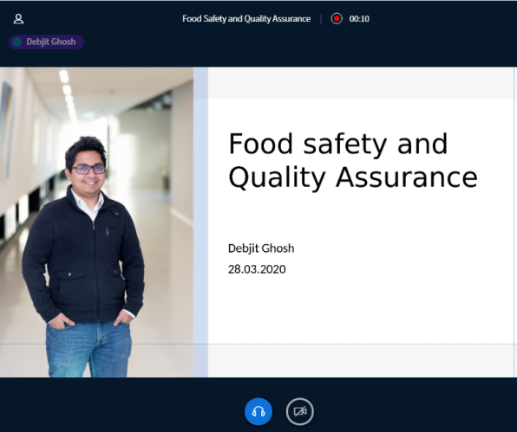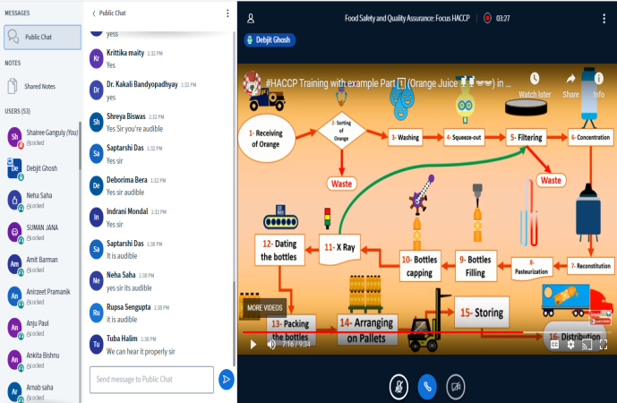

- Interactive session on Minimally Processed Foods on 15 April, 2020 by our esteemed Alumniof Dept. of Food Technology, Mr. Arka Roy Chowdhury, Krishi Projukti Sahayak, Govt. of West Bengal.
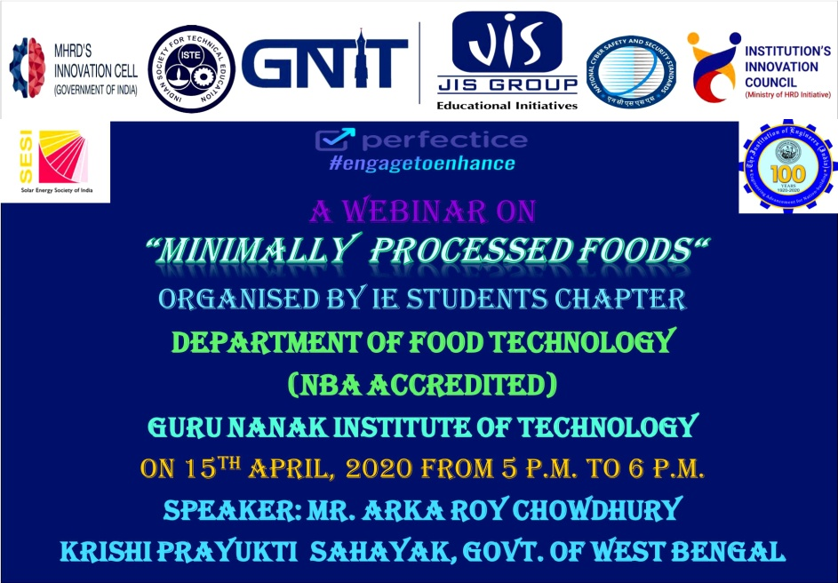

- “Digital Alumni Meet: FT-Bridge 2020” on 17th May. About 65 alumni of different batches gather in the online platform and rejuvenate their memories with the faculty members and the current students of 3rd year Food Technology. All alumni share their experience of becoming a Food Technologist and interact with the current students, which make a “Bridge” between the present and past GNITians.

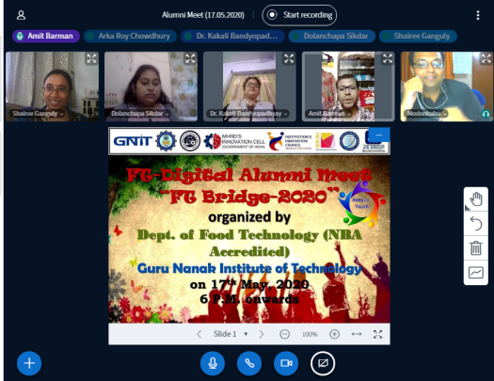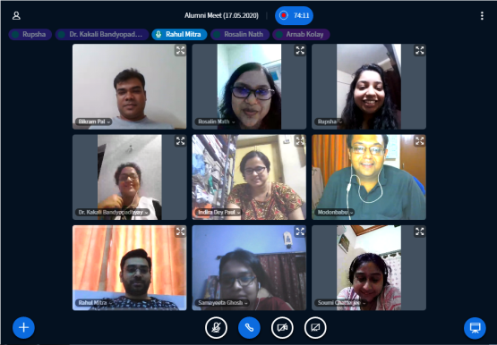

- Webinar on BIOSENSOR: AN INNOVATIVE APPROACH IN FOOD PROCESSING by distinguished alumni of dept. of Food Technology, Speaker: Ms. Ishita Auddy, Ph.D. Scholar (Food Process Engineering), Indian Institute of Food Processing Technology(IIFPT), Thanjavur(MOFPI),Govt. of India
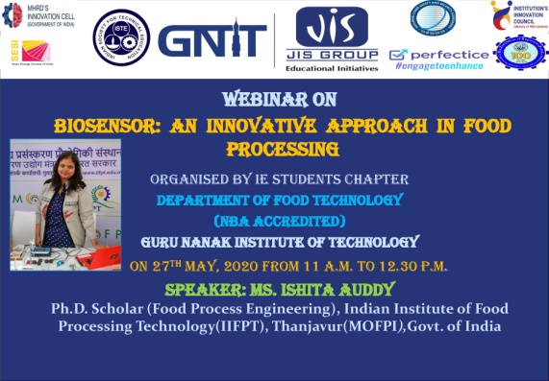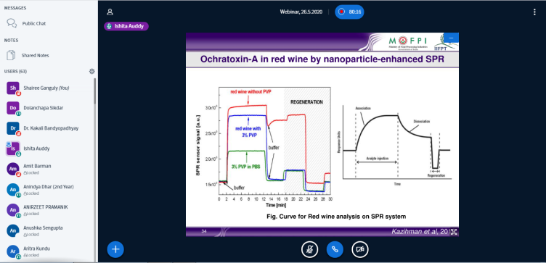

- Food safety workshop: One distinguish alumni, Mr. Ushnil Datta along with some current students and faculty members of the department has conducted a three day camp from 6th to 8th March, 2020 on “Spreading Awareness to the Society about Adulteration in Food” at “Dol Mela” organised Baijayanti & AIWC Canal West Constituent Branch.
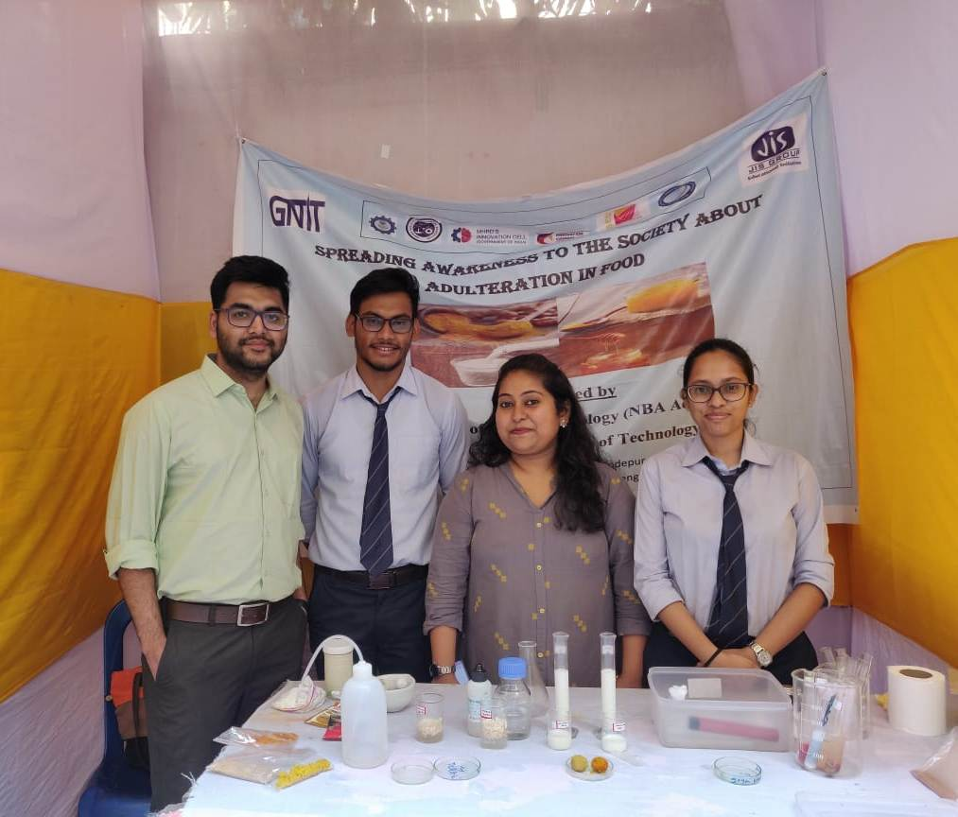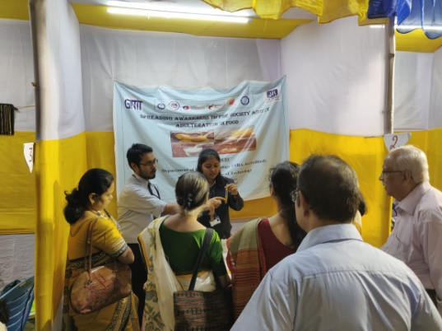

- In the event of “Alumni Entrepreneur Talk”, distinguish Alumni and Entrepreneur from Dept. of Food Technology, Mr. Soumyadeb Bhattacharyya, Proprietor,” K for Kakes”, has conducted a very interactive session with the 1st year students of the department in their Induction Programme, organized by Dept. of Food Technology. (August, 2019)
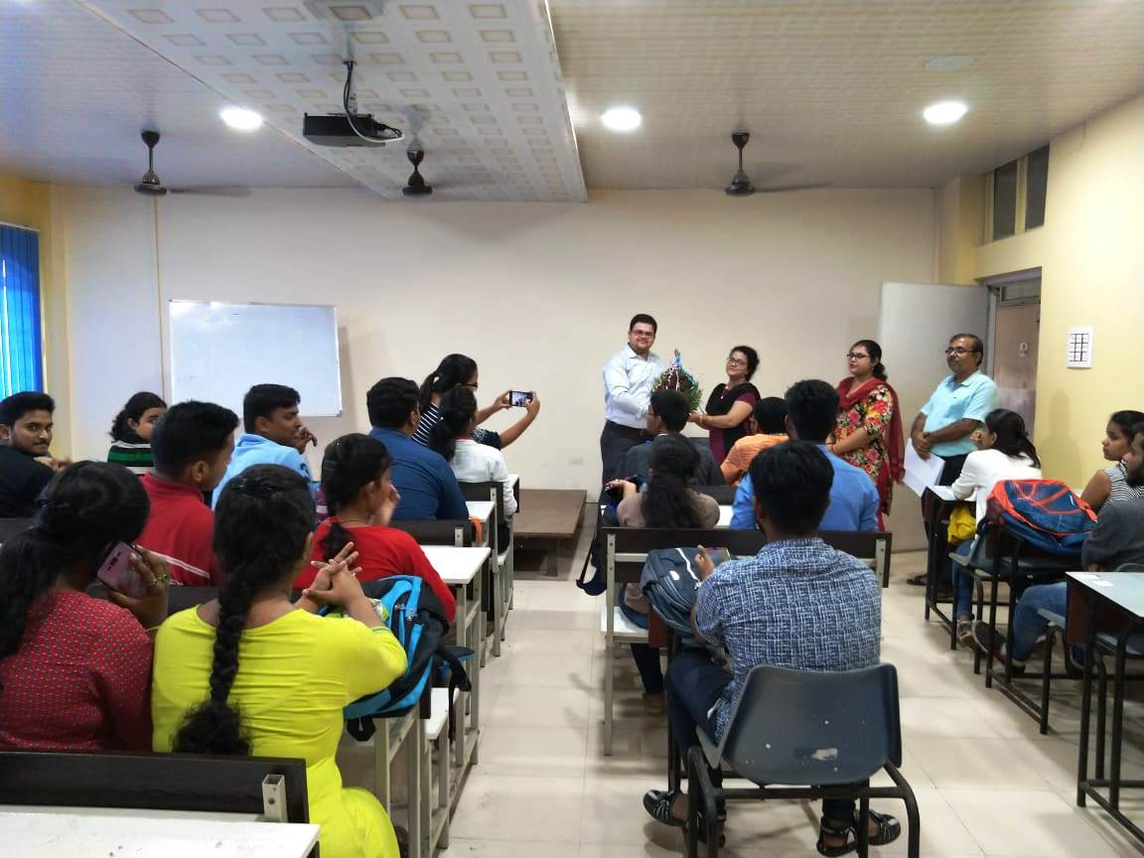
- Dept. of Food Technology organised an Industry-Alumni meet on 27th February, 2020.
One of the distinguished Alumni of the department, Mr. Tanmoy Bose, Application Architect – IBM, Switzerland, has interacted with GNIT-ians.
He conducted a very motivational session to the current students of the department. In the session he discussed about how to prosper in interdisciplinary field being a Food Technologist. This session helped the students to understand how to groom themselves for the upcoming Campus and Off-Campus Drives.
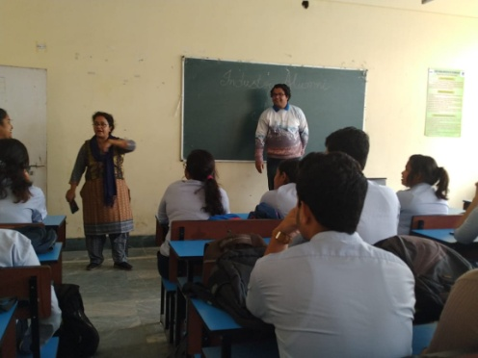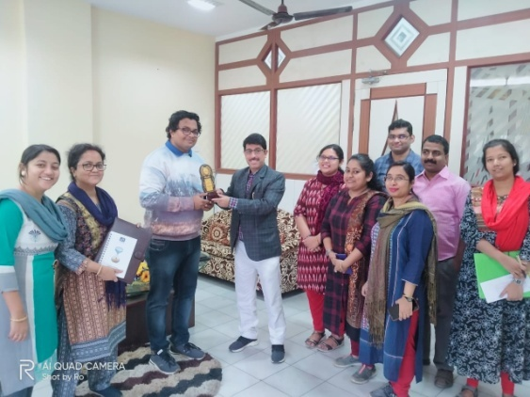

- Dept. of Food Technology, GNIT organized an Industry alumni meet on 17th October, 2019. One of the distinguished Alumni of the department, Mr. Ushnil Dutta, Dairy Technologist, Almarai, Saudi Arabia conducted a very motivational session to the current students of the department. In the session he discussed about the different job opportunity of Food Technology in abroad as well as in India. This session helps the students to understand how to groom themselves for the different job opportunities.
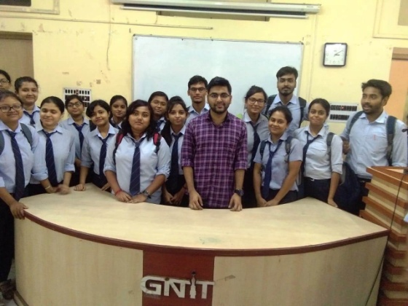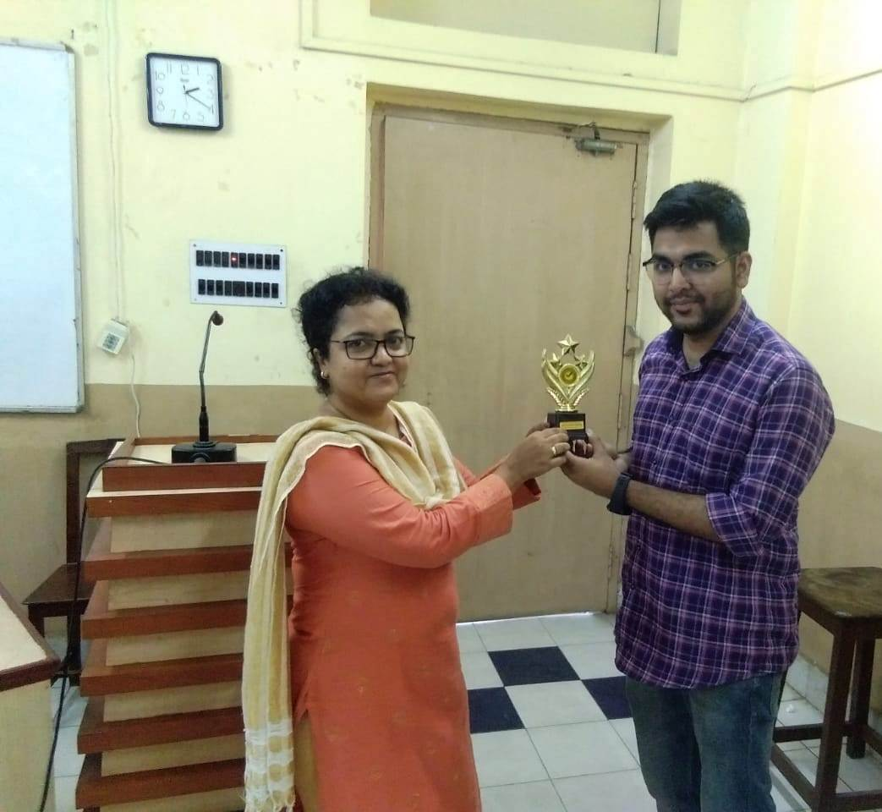

Academic year: 2018-2019
- Invited Talk on “New research area of Food Technology” by Alumni Mrs. Dolanchapa Sikder, Research Scholar, Jadavpur University , 11.8.2018.
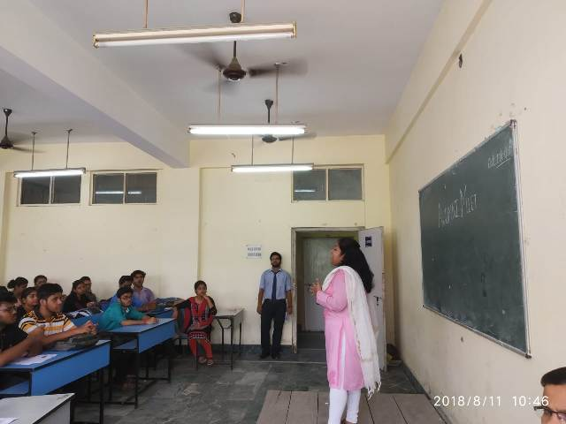

- Alumni Entrepreneur Meet: A New Look to The Modern Food Sector by Mr. Soumyadeb Bhattacharyya, proprietor of “K for Kakes”.
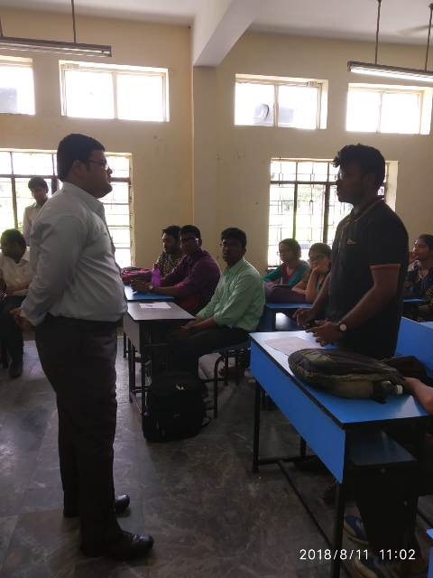

- Interactive session-”Changing Dynamics of the Food Industry with a Special Reference to Alcohol Industry” by Distinguished alumni of Dept. of Food Technology, Mr. Mousam Das.
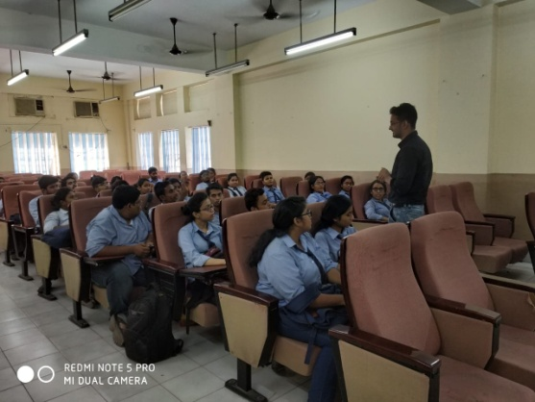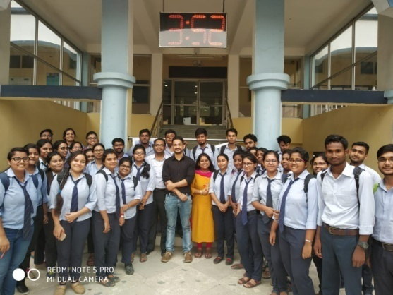
Academic year: 2016-2017
- Invited talk on “Recent development of cheese and alcoholic beverage manufacturing industry” by two distinguished alumni of Dept. of Food Technology, Mr. Abhishek Paul, Team, Manager, Cheese Plant, Almarai, AUE and Mr. Biswanath Mukhopadhyay, Senior Tech. Executive, United Breweries.
