**Products Developed by ASHU:**

At a critical time, during a raging pandemic, the ASHU Dept came up with two products of great usefulness and functionality, a hand sanitizer and floor cleaner, which helped in aiding the sanitization drive to curb the spread of the pandemic.

**Preparation of organic floor cleaner**

Team Chemistry, GNIT, comprising of Dr Sreyasree Basu, Dr Mainak Debnath, Dr Indrajit Bhattacharjee and Mr Chandan Bhattacharyya, came up with their new organically developed floor cleaner, “Safe Touch.” It is totally safe, acid-free, gentle on the hands and with a refreshing lime fragrance.

***Safe Touch* floor cleaner—the gift from Team Chemistry**

**hemistry**

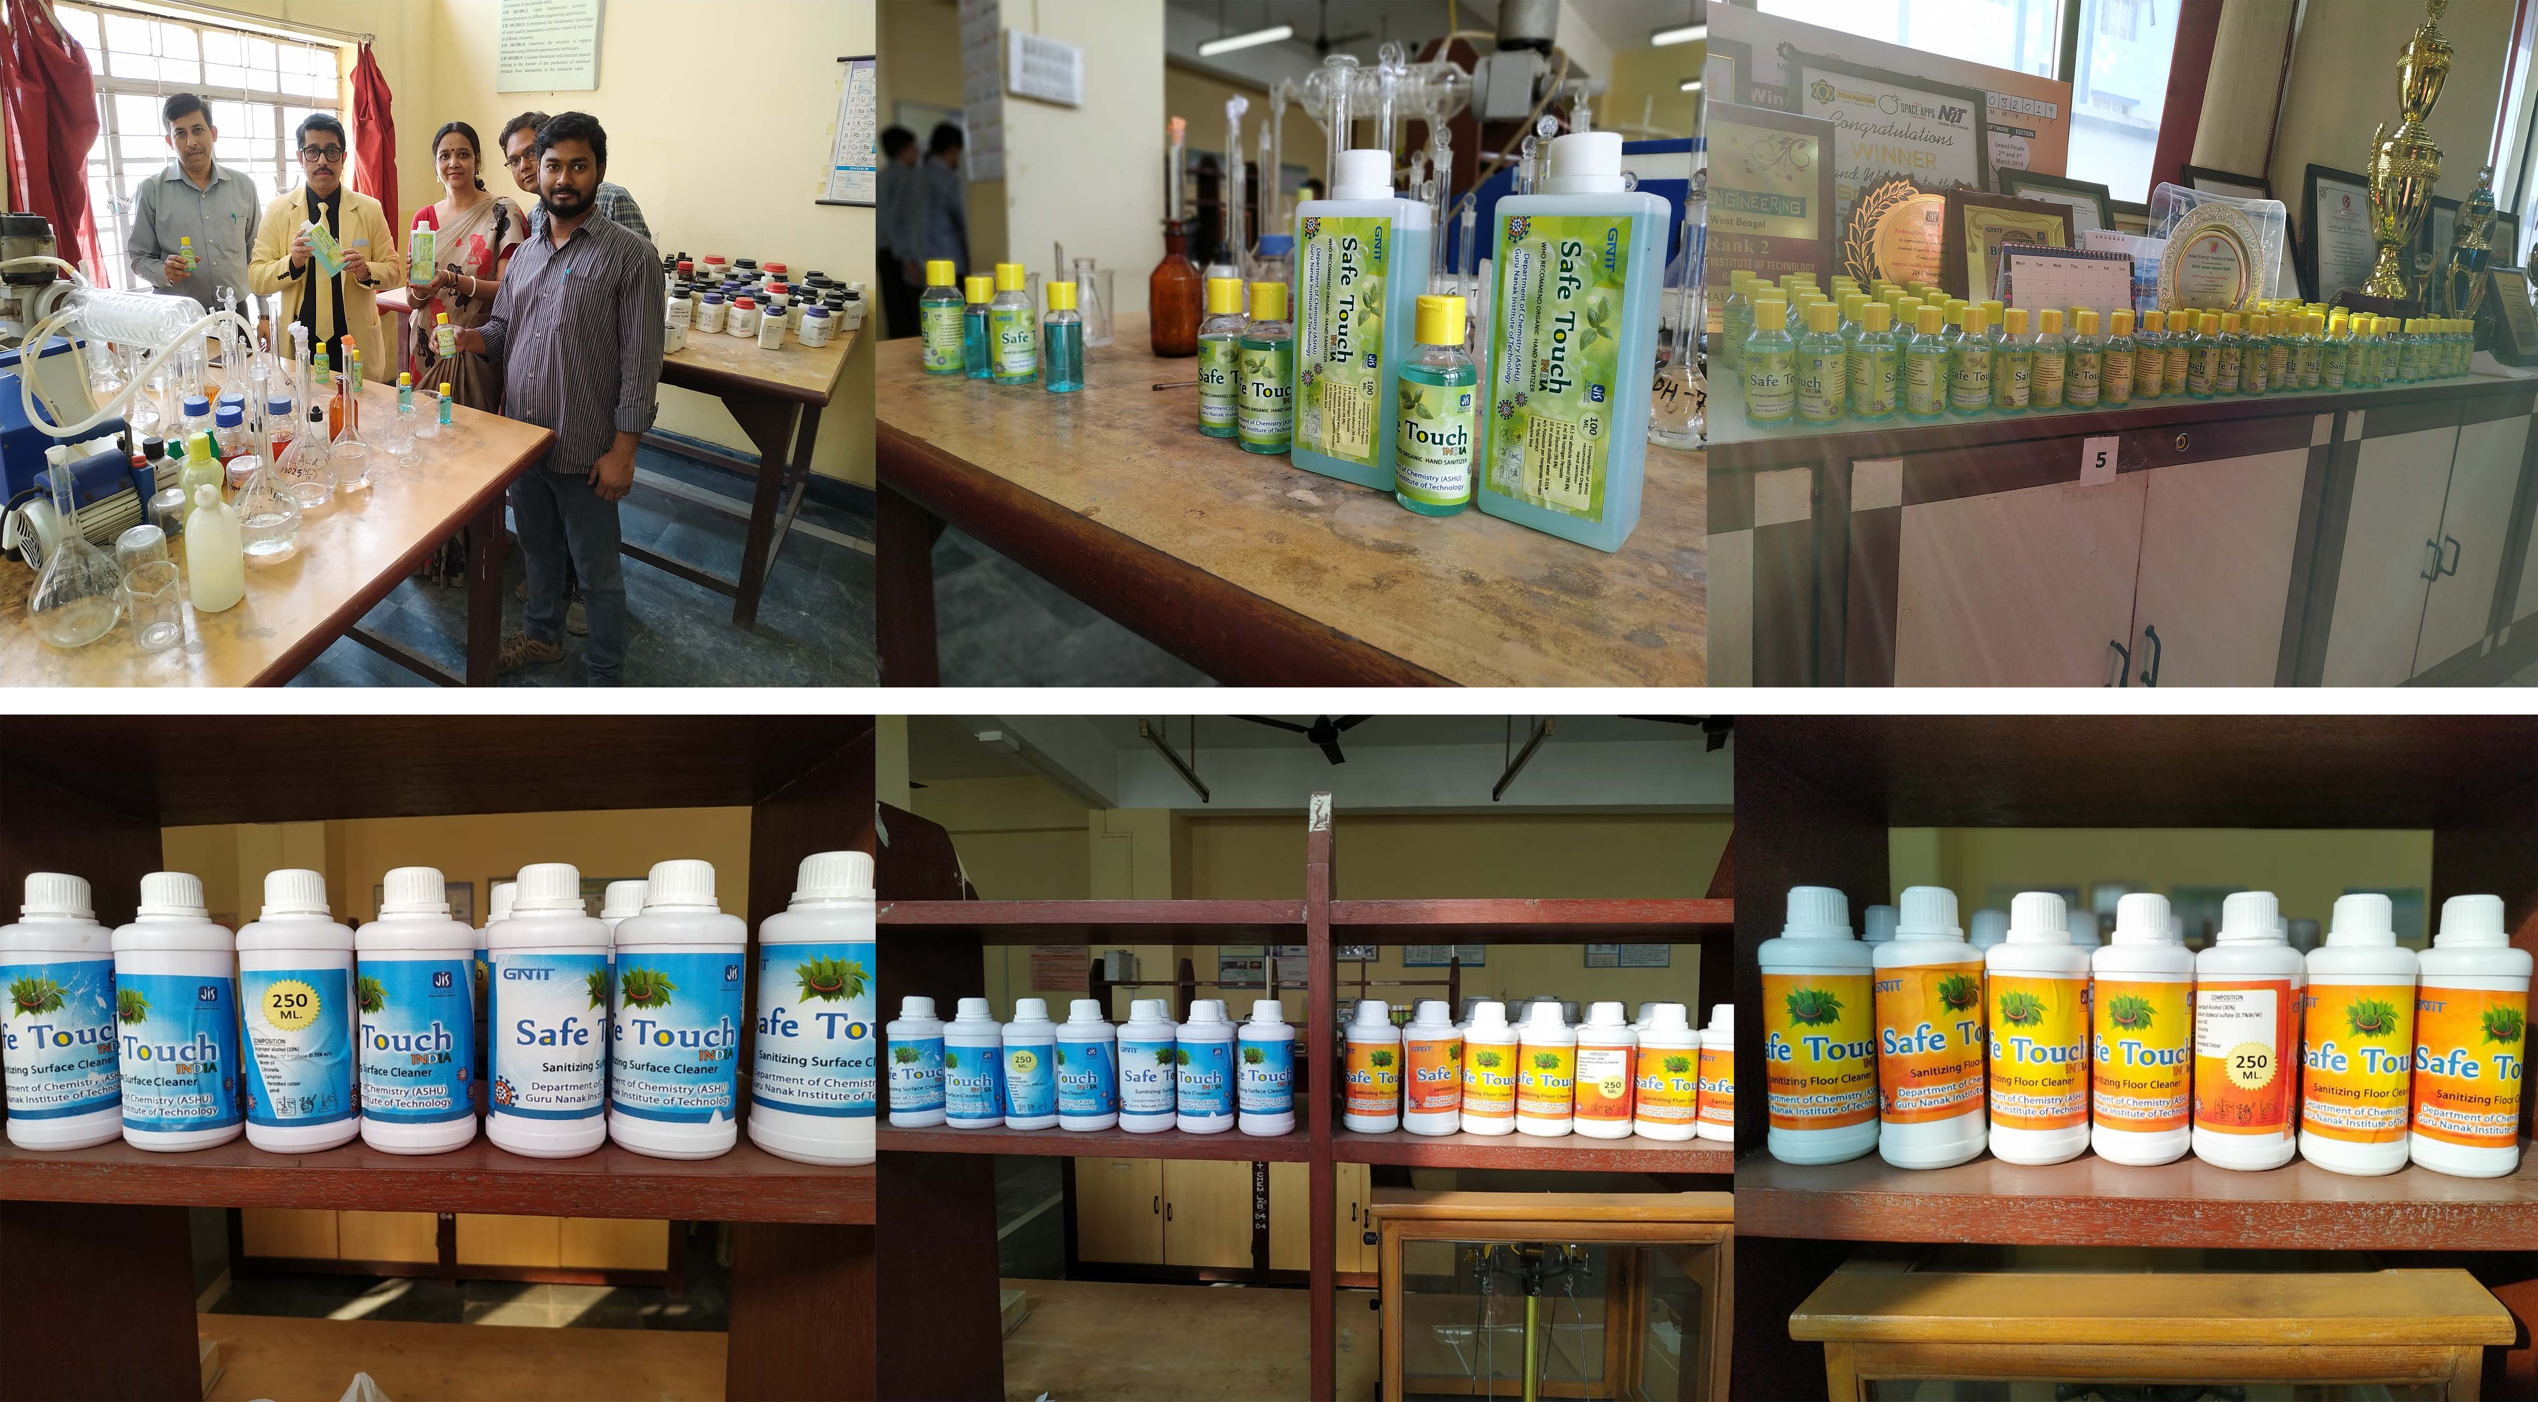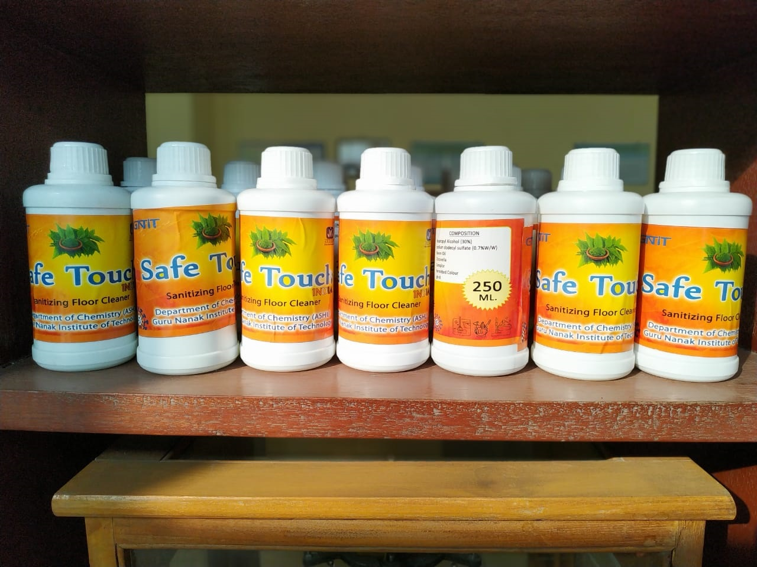

**In-house preparation of hand sanitizers**

To combat COVID-19, and to overcome the huge scarcity of sanitizers, the Faculty members and JTAs of the Department of Chemistry manufactured and launched the Safe Touch Hand Sanitizer - the WHO recommended Organic Hand Sanitizer on 19 and 20 March 2020. The lead role was taken by Dr. Sreyasree Basu Section-in-Charge, a doctorate in Medicinal Chemistry, Dr. Mainak Debnath, Dr. Indrajit Bhattacharyya and Mr. Chandan Bhattacharyya in making the Sanitizer in their Labs. The sanitizer was distributed to all office staff of GNIT, security guards, staff of store, staff of the office Campus supervisor and it was sent to JIS corporate Head Office.



