**Industry Mentor Meet:**

The department organised an Industry mentor meet for the students on 29.11.2020. It was our privilege to have two renowned industry experts as mentors - **Mr.Rajmohan Dey Sarkar ,Director Technology Services, Ardent Computech** **Pvt. Ltd** and **Mr. Pranab Sinha Chaoudhury, Ex Dy General** **Manager(Maint.), W.B.P.D.C.L, A Govt. of West Bengal Enterprise.** The program ended with an interactive session with the students.

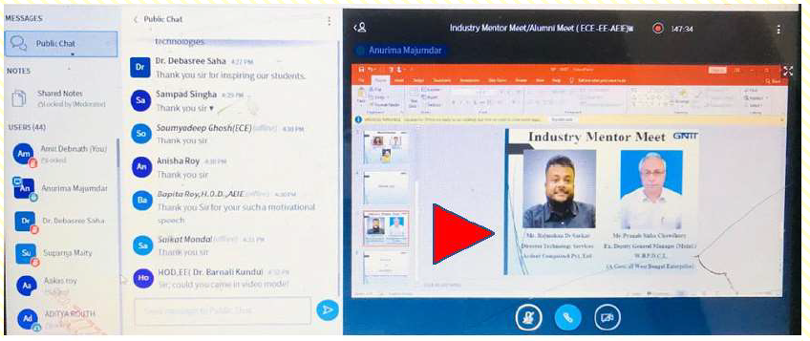

**International Seminar (Guest Lecture)**

The Department of Electronics & Communication Engineering organised an One day International Seminar on Quantum Mechanics in Electronics on 8th April 2020. The seminar was organised totally on digital platform. The event was coordinated by Dr. Sunipa Roy, HOD , ECE and Ms. Anurima Majumdar, Asst. Prof, ECE. Mr Rajeev Singh who is currently working as research fellow in the Institute of Neuclear Physics , Polish Academy of Sciences , Krukow, Poland was the invited speaker for the event. Almost 150 students participated along with the faculty members and JTAs.



 Industry Mentor Meet:

Electronics and Communication Engineering @ GNIT organised *Industry Mentor Meet*on 22 June 2020.

Mr. Koushik Sett, Test Engineer, INFOSYS was the invited Speaker. He is our Industry Alumni Mentor of the department for the last 2 Years.

He addressed issues like the need for knowledge in coding in ECE, Job Scenario after Lockdown, importance of Higher Studies and how students should prepare themselves. 150 Students from 2nd Year and 3rd Year participated enthusiastically as they interacted with Mr. Koushik Sett.

