M.Tech ECE Website Document
Executive Summary
The Electronics and Communication Engineering Department commenced in the year 2003 and now runs one undergraduate, one postgraduate program (M. Tech in ECE), Ph. D. program under JIS University/MAKAUT and also one 3 years diploma program affiliated by WBSCTE. The programs offered by the department are the most sought after branch in Engineering by top WBJEE rank holders and other aspirants from across the country. All the programs are accredited by NAAC which is compulsorily outcome based, planned to meet the Industry needs and also Research organization. The program contents are upgraded on annual basis with involvement from industry experts, academia and reputed research institutions.
Experienced faculty members all of whom are engineering postgraduates and most of them with PhDs as well, support three core specializations (VLSI & Microelectronics, Communication, Image processing &Embedded system) in the Department. The curriculum includes a strong self-study component and mini projects at all levels so as to develop the students' independent analytical abilities. Opportunity for innovation and incubation is provided at this stage to successful projects by the institute for industrial standards. The department offers financial support to its young faculty for cutting edge research and also encourages them to undertake sponsored research from industry and government agencies. Presently several projects sponsored by UGC, AICTE are under way in the department. Also, department provides healthy environment to students and faculties to carry out inter department collaborative research in area like robotics, human computer interface, SMART sensor etc. Software Simulation environment (Tanner SPICE, Mentor Graphics, Matlab 2014b, TCAD, HFSS, Qualnet, COMSOL Multiphysics, Intellisuite, TMS Kit with Code Coposer Studio etc.) and state of the art are available.
Having undergone such a robust academic program under the supervision of highest quality faculty members, all passing out students of the department are capable of envisage, planning and developing big projects of commercial and research interests in their respective field of expertise.
We strive to train and empower our students who will make the world a better place by using power of engineering principles, techniques and systems.
Welcome to our Department!

Objective of the Programme:
To create technical professionals with practical mindset and problem solving abilities, for solving problems in a variety of business, scientific and socials contexts, to serve people. Students are imparted with the knowledge of the design, development and analysis of software and hardware related to computational devices.

Vision:

Impart quality education to create world class technocrats and entrepreneurs with new ideas and innovations to meet industry expectations through advanced research.

Mission:

To educate our graduate engineers to develop and deliver quality academic programmes in the emerging and innovative field of Engineering to empower the undergraduate engineering students to meet industry standards.

To empower practicing engineers with the state of the art technology to meet the growing challenges of the industry and society.

To carry out high quality research through constant interaction with research organizations and industry.

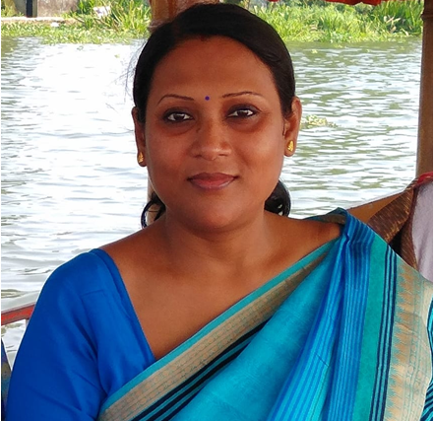

HEAD OF THE DEPARTMENT MESSAGE

Dr. Sunipa Roy – Being the HOD of Electronics and Communication Engineering department, I am pleased to convey my opinion about the departmental development which offers four years full time B-TECH program in ECE since 2003. The course is accredited by NBA. The average passing result is excellent in the department. Almost 10-15% students scored above 9 DGPA. Apart from this we are running P.G. Programs, M-TECH in Electronics & Communication Engineering since 2009. The department of ECE offers premier professional technical training that keeps in pace with the latest developments in the field of Electronics and Communication Engineering. We have excellent infrastructure, highly experienced faculties and professionals, associated with research work which collectively ensure dynamic and vibrant environment in the campus. Some of the Faculty members of this department went to attend International Conferences in abroad. The department organized so many International & National Educational Programs (i.e. IEEE sponsored Seminars, international conference- published in IEEE Xplore Digital Library, Faculty Development Programs and one day educational Industrial visit). There are so many events like Paper presentation, Poster presentation, Technical Quiz contest, Technical Report writing Contest & Technical Workshop. There are more than 100 publications are done by the faculty & students in National & International Journals & Conferences. Furthermore six UGC projects, one MODROB are completed in last few years with consultancy. Many of our Alumni are settled in abroad and also many of the students are placed in so many reputed Govt sectors and Private Sectors Company and Research Organizations. There is also separate Departmental Library in the ECE department. We have also Project lab in our department. The Department is constantly evolving towards greater heights to serve the needs of the society and meet the aspirations of the student community.

Distinguished Alumni:

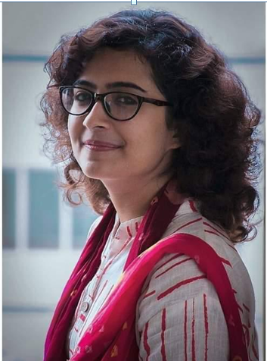

GargiMukhopadhyay(M.Tech,, 2020 passout)

Hallo Everyone. Myself Gargi Mukhopadhyay, completed M.Tech from ECE department of GNIT. Currently, I am working as an Associate Engineer in fiber network delivery of British Telecom. I am very thankful for all of my teachers for their continuous support. The college provided an extensive range of infrastructure support which helped in developing skills and indepth knowledge. The Trainings being focused on specific areas also helped a lot to crack the interviews. I proudly feel that I cherished every moment of my college life.

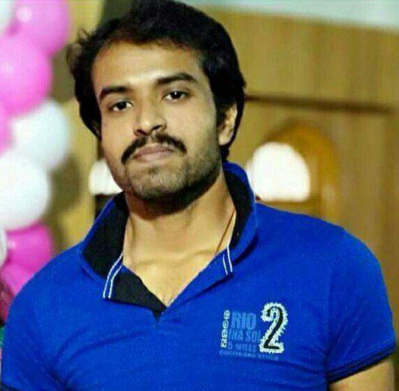

Shatadru Biswas

(M.Tech,2020 passout)

I did my M.Tech in electronics and communication engineering from GNIT. I have learned a lot from my professors and mentors. They were very supportive and encouraged us in all things to grow up in our life. So, overall my GNIT college life was so beautiful, nobody can forget those days in their life and those days will never be back again.

Ankita Ganguly (M.Tech, 2015 passout).

I am Ankita Ganguly currently working in IBM India, Bangalore. I did my M.Tech from GNIT in 2015. I am lucky to choose this college for my post-graduation as this college has given me the right opportunity to build my career.
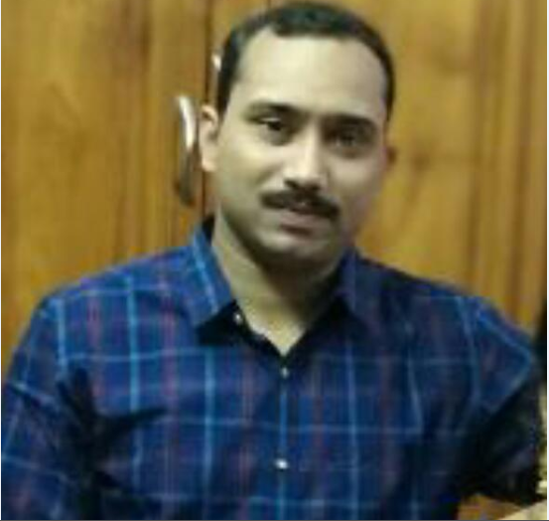

Som Subhra Mondal (M.Tech,2015 passout)

Hi Everyone. I am Som Subhra Mondal completed M.Tech from Electronic and Communication Engineering Department of Guru Nanak Institute of Technology. Presently I am working as Lecturer in JISSP, Kalyani.
I had wonderful experience throughout my two years of M.Tech. All the professors are very helpful and friendly. I believe that all the knowledge I have earned from this college will always help me grow in my life and I shall always remain thankful for it.

Current students
SrijoniMalakar

Hi Everyone, I am Srijoni Malakar final year M.tech student of Electronics and Communication Engineering Department of Guru Nanak Institute of Technology, feel very proud of my institution. Our college gives us all the opportunities to enhance our knowledge and technical skills. The faculties of our college are very supportive and understanding. The labs are well equipped with all the analog, digital kits and instruments. Our library has all the resources to help us to get all study materials.

Apart from these, even now during this critical condition,when this pandemic of COVID-19 is going on, our college has given us the facility of digital classroom, where we can continue our regular classes and prepare for semester exam. If any students, who has an interest in M.Tech and want to settle their future in this field,then GNIT will give you every path to achieve that.
I highly recommend our college to anyone wanting a career helping people and one that provides flexibility and incredible job satisfaction.

BidushiSaha

I am BidushiSaha, currently studying in second year M.Tech.Our college has well equipped labs and facilities .Our department has many experienced PhD faculties.I had also done by B.Tech from Guru Nanak Institute of Technology.

Since the Coronavirus pandemic and the ensuring lockdown have forced our college to shut temporarily, in this situation our college took the initiative of doing their best to provide support for e-learning through myperfectice whiteboard platform. It’s a great initiative taken by our college where our teachers are providing the online classes and also helping out to cope up with our syllabus.

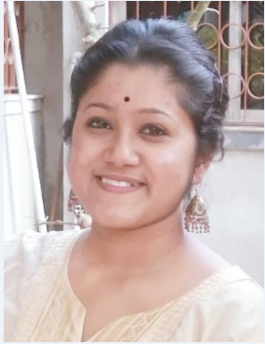
SarnaliChakraborty
Halo Everyone, I am SarnaliChakraborty final year M.tech student of Electronics and Communication Engineering Department of Guru Nanak Institute of Technology.
College forms an important part of life of any well-read man as it not only imparts wisdom out of books to students but also teaches numerous life skills. My college GNIT is one such place that has not only helped me to become a well taught engineering graduate but also a responsible citizen. Yet the best thing about my college is the curriculum design which stresses upon practical equivalent to theory in every semester. Not only that, we can get the opportunity of soft skill, aptitude classes and can take part in campus interview. . I feel proud to be a student of this college. I would like to thank my college for giving us this opportunity to learn from anywhere in this pandemic situation.

