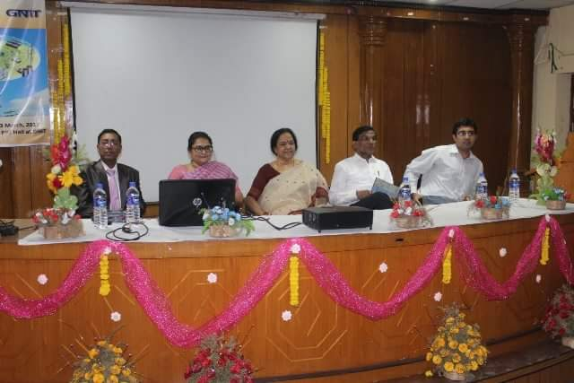

Expert Lecture:
Institute arranges various expert lectures for students and faculties. The objective of expert lectures is to explore particular subject with interaction with industry experts. Expert session provide platform to students to express their ideas and view. Student gets benefit to relate theoretical with practical inputs of field. Series of such session pour an extra enthusiasm to student to give practical approach to their study.
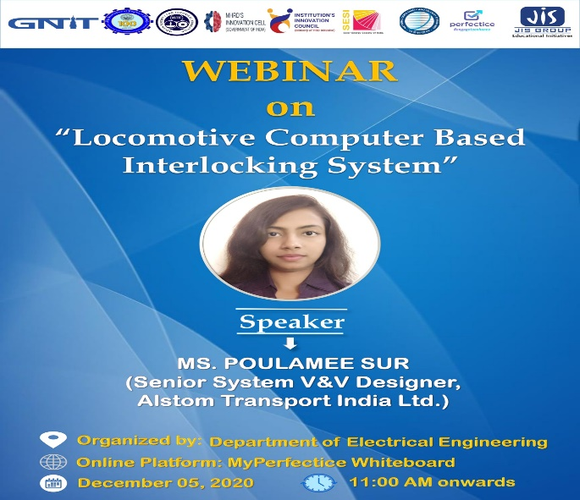
Webinar entitled “Impact of Solar Technology on Renewable Energy Sector”

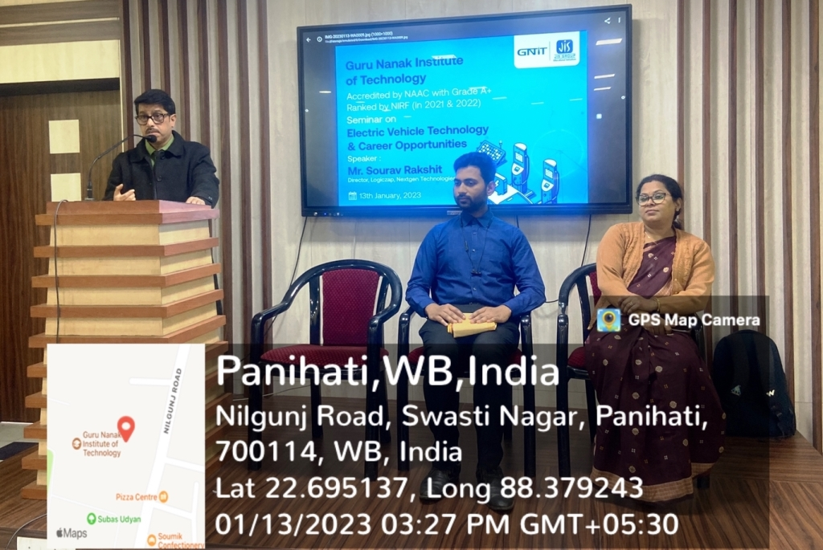
One Day Seminar on “Electric Vehicle Technology & Career Opportunities”
- Alumni Talk
There are several benefits of having an engaged alumni community. Alumni engagement leads to lifelong alumni relationships, alumni helping the current students choose the right career stream or college, internships, placements and donations or can even fund scholarships. Alumni management, when done in the right way, can help current students in their career success and earn a reputation for their institutions.
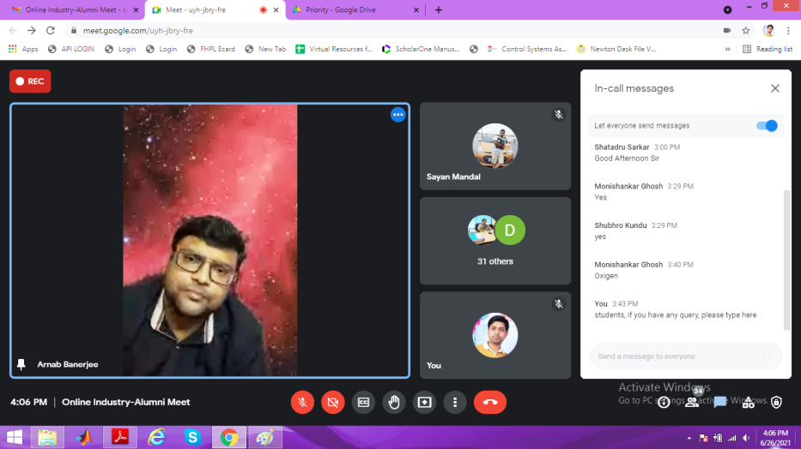
Online Industry-Alumni Meet on “overview of Power Plant”
Webinar on “DC-AC Power conversion: Multilevel Inverters”

The Department of Electrical Engineering, GNIT organized a Webinar on “DC-AC Power conversion: Multilevel Inverters” on 12th Feb , 2021 from 02.00pm for B. Tech and Diploma Electrical Engineering Students.

Alumni of Electrical Engineering Department,GNIT “Mr. Bidyut Mahato”, SENIOR RESEARCH FELLOW, IIT(ISM), Dhanbad was the Resource Person (External Speaker) of the Webinar.

Mr. BIDYUT MAHATO shared a brief knowledge on DC-AC Power conversion: Multilevel Inverters. He describes how a multilevel inverter is capable of providing desired alternating voltage level at the output using multiple lower-level DC voltages as an input.

The Webinar was coordinated by Dr. Barnali, HOD, Associate Professor, EE and Mr. Suman Ghosh, Assistant Professor, EE Finally the session ended with a series of questions and answers.

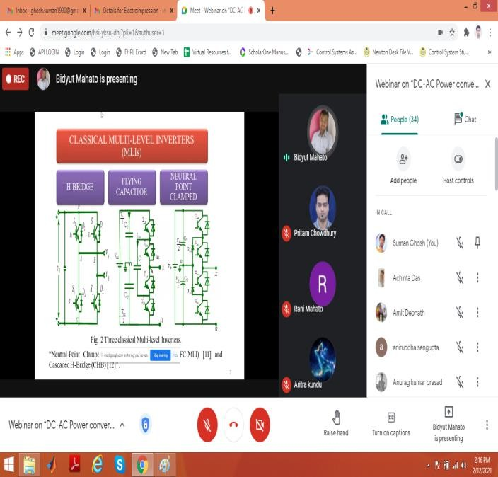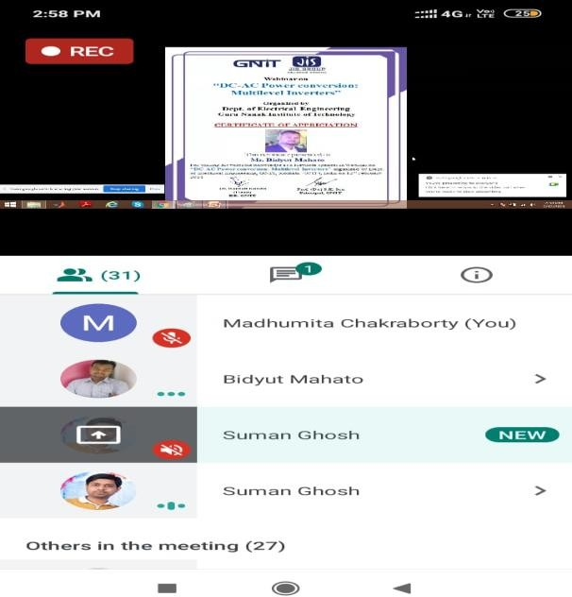

“Expert Session on Battery Modeling”
The Department of Electrical Engineering, GNIT in collaboration with MathWorks conducted an “Expert Session on Battery Modeling” on 12th February 2021 between 10:30 a.m. and 12:00 p.m.

The Session was facilitated by Ramana Anchuri, Engineer from the Education Team at The MathWorks, working with academia in India. He completed his undergraduate studies in Electrical and Electronics Engineering and Masters in Power Electronics from JNTU Hyderabad. Prior to joining The MathWorks, he worked for academia and in industry.

He worked with KPIT Pune as senior software engineer where he is responsible for control design for automotive engine systems and with CYIENT limited as senior software engineer responsible for developing, verifying and validating aircraft engine control systems. He is passionate about teaching and learning, and his current interests include Power Electronics and Control Design, Model Based Design and Code Generation.

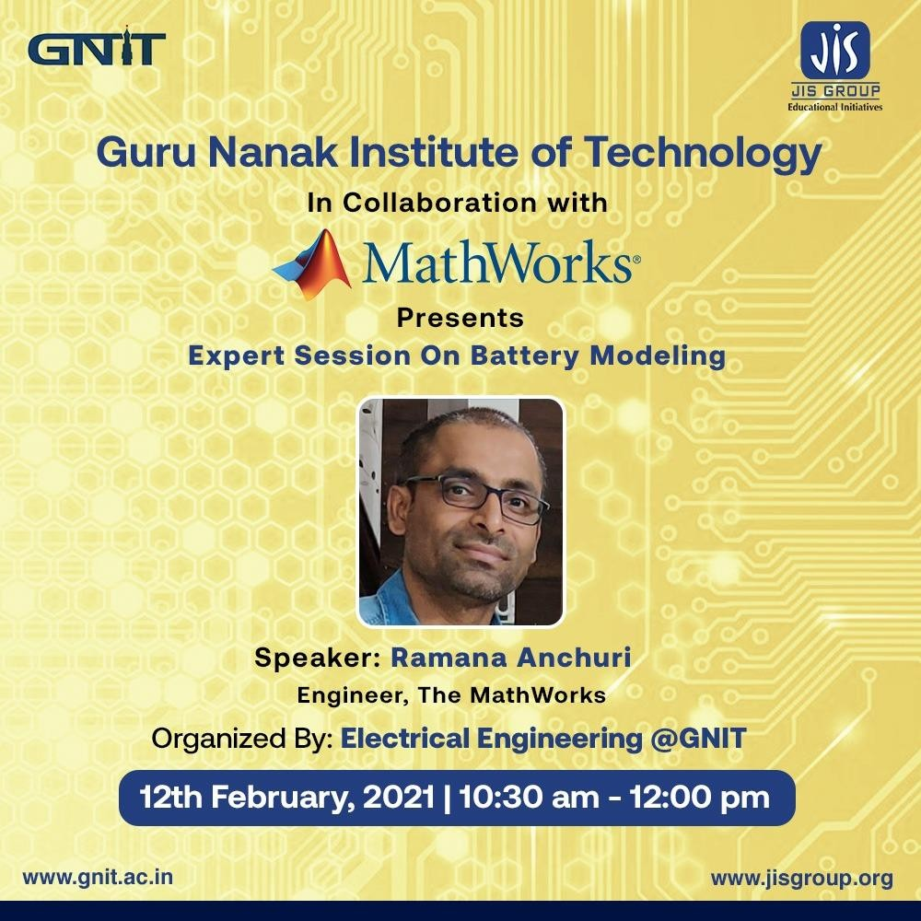

“Expert Session on Electric Vehicle”

The Department of Electrical Engineering, GNIT organized a Workshop on Expert session on Electric Vehicle on 11th Feb 2021 for from 10:30 AM to 12:00 PM.
The Session was facilitated by Debanand Singdeo Education Technical Evangelist at MathWorks India Private Limited (Pune). Alumni:Visva Bharati, Santinike tan, IIT Bombay, Dept of Energy Tech., Aalborg University, Denmark.
Debanand Singdeo, works as an Education Technical Evangelist at MathWorks India Private Limited (Pune). In this role, he collaborates with researchers with the aim of accelerating the pace of innovation in science and engineering. Also, he works closely with academic institutions for effective utilization of MathWorks resources in education. He has Bachelor’s degree in physics from Visva Bharati University, Shantiniketan, followed by M.Sc.-PhD degree from the Department of Energy Science and Engineering, IIT Bombay. His prior research experience is in the area of modeling and simulation of renewable energy systems. In previous roles, he has worked as a postdoctoral fellow in the Department of Energy Technology, Aalborg University, Denmark.
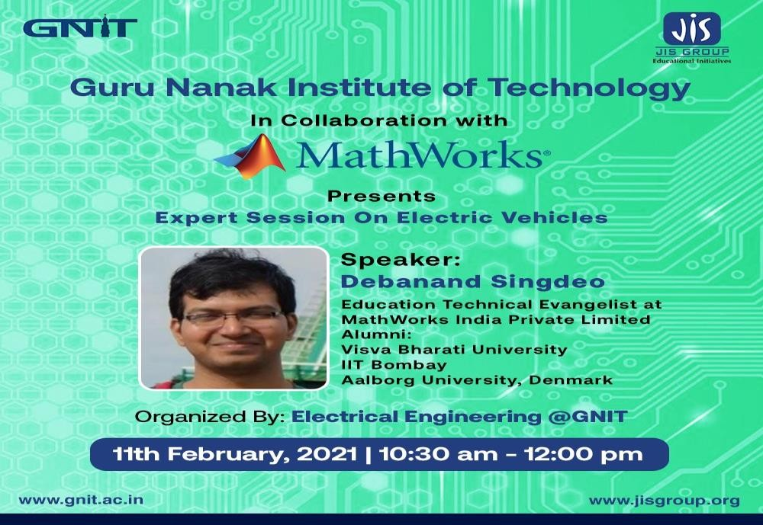

Webinar on “Impact of Solar Technology on Renewable Energy Sector”

The Department of Electrical Engineering, GNIT scheduled a Webinar entitled “Impact of Solar Technology on Renewable Energy Sector” on 6 February 2021 between 11:30 a.m. and 12:30 p.m.
The Webinar has been facilitated by Mr. Somnath Chatterjee @ Skillectron India Pvt. Ltd.
In total there was huge number of participants present in the Webinar including faculty members, staff and students from B.Tech as well as Diploma. Here students got the exposure to learn the new technologies which is very much emerging these days in locomotive industries
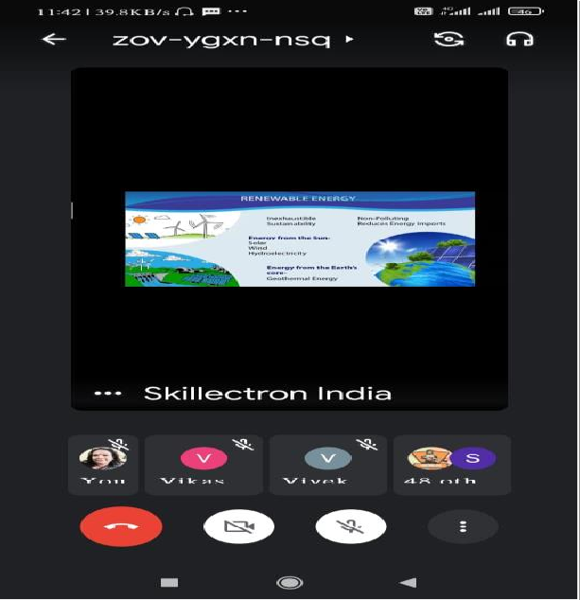
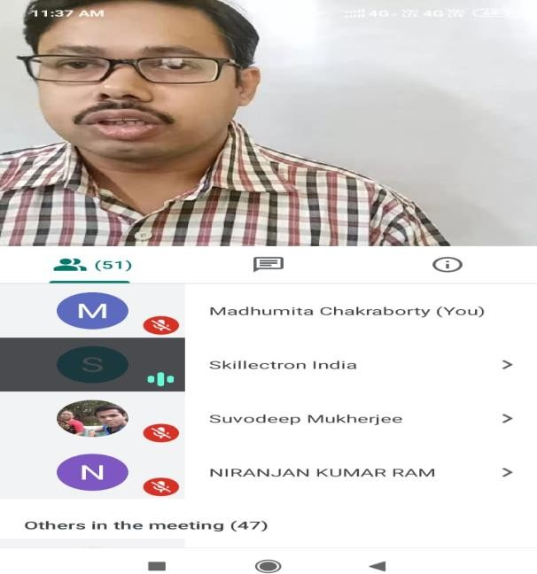
The entire event was coordinated by Ms. Madhumita Chakraborty, Assistant Professor EE and Mr. Pritam Chowdhury, Assistant Professor EE

Webinar on “Electrical CAD Design”

The Department of Electrical Engineering, GNIT organized a Webinar entitled “Electrical CAD Design” on 19th March, 2021 from 6:00 PM to 8:00 PM. Where not only students but all faculties and staffs were also involved.

The Webinar was facilitated by experts from Tech Tree Technologies

They discussed about Designing concepts of AUTOCAD in both 2-D and 3-D. Students from the Department of Electrical Engineering along with the Faculty Members and Technical Staff had attended the program. Students from all years of B.Tech as well Diploma have attended the Webinar and the session was interesting and interactive.
The Webinar was coordinated by Dr. Barnali Kundu,HOD & Associate Professor, EE and Dr. Aveek Chattopadhaya, Assistant Professor, EE

