GUEST LECTURES ORGANISED
CAY (2022-23)

Sl. No. | Organized by | Event Name | Inter/ Intra College/ National | Date | Picture
1 | ECE in collaboration with IEI Student Chapter | Workshop on “Methodology for Research on Performance Pedagogy” | Intra College | 25.07.2022 | 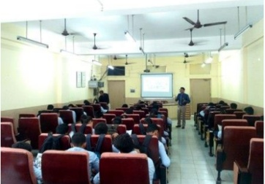
2 | ECE in collaboration with IEI Student Chapter | Seminar on “Different Aspects of Intellectual Property Rights” | Intra College | 09.08.2022 | 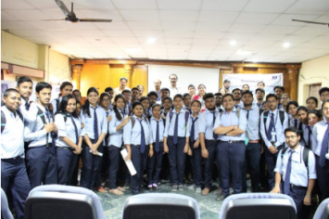
3 | ECE in collaboration with IEI Student Chapter | Seminar on “Linear Integrated Circuits” | Intra College | 07.09.2022 | 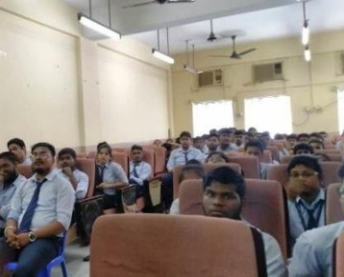
4 | ECE in collaboration with IEI Student Chapter | Seminar on “Cloud Computing" | Intra College | 22.11.2022 | 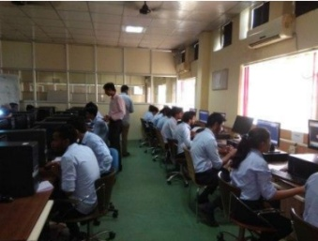
5 | ECE in collaboration with IEI Student Chapter | Workshop on “An Overview of Research Methodology” | Intra College | 05.12.2022 | 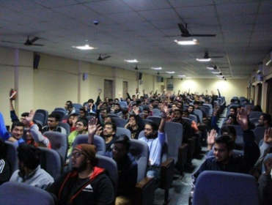
6 | ECE in collaboration with IEI Student Chapter | Workshop on “Robotics and Manufacturing Equipment” | Intra College | 20.01.2023 | 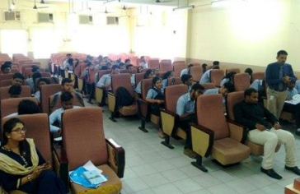
7 | ECE in collaboration with IEI Student Chapter | Workshop on “Microcontroller Based Embedded System Design” | Intra College | 01.02.2023 | 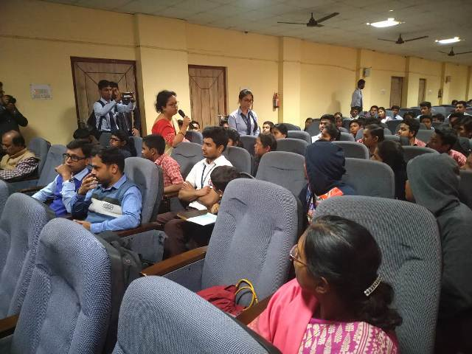
8 | ECE in collaboration with IEI Student Chapter | Seminar on “Deep Learning with Python” | Intra College | 03.03.2023 | 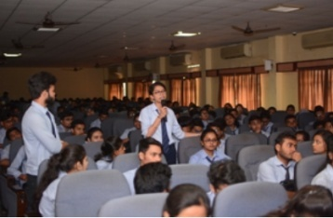

CAYm1 (2021-22)
Sl. No. | Organized by | Event Name | Inter/ Intra College/ National | Date | Picture
1 | ECE in collaboration with IEI Student Chapter | Seminar on “Physics in an Astronomy Context” | Intra College | 13.07.2021 | 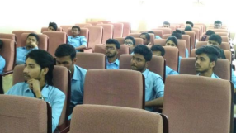
2 | ECE in collaboration with IEI Student Chapter | Seminar on "Role of IPR in Economic Growth" | Intra College | 03.11.2021 | 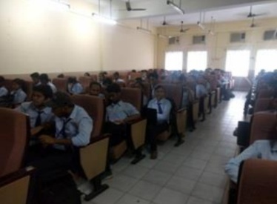
3 | ECE in collaboration with IEI Student Chapter | Seminar on “Internet of Things and its Applications” | Intra College | 04.03.2022 | 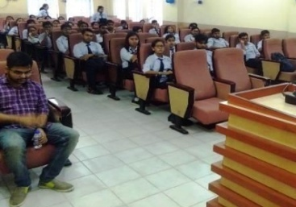
4 | ECE in collaboration with IEI Student Chapter | Seminar On “Entrepreneurship Development – Power of Ideas” | Intra College | 01.04.2022
5 | ECE in collaboration with IEI Student Chapter | Seminar on “Basics of IoT and its Applications” | Intra College | 22.04.2022
6 | ECE in collaboration with IEI Student Chapter | Online Seminar on “Software Development Life Cycle for Web Application” | Intra College | 12.05.2022 | 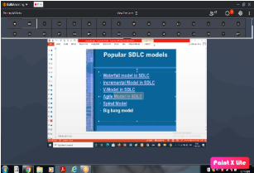
7 | ECE in collaboration with IEI Student Chapter | Seminar on “sustainable development challenges and prospects” | Intra College | 28.06.2022 | 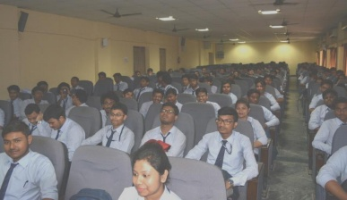
CAYm2 (2020-21)
Sl. No. | Organized by | Event Name | Inter/ Intra College/ National | Date | Picture
1 | ECE in collaboration with IEI Student Chapter | Online Seminar on “Machine Learning and their Scope” | Intra College | 17.10.2020 | 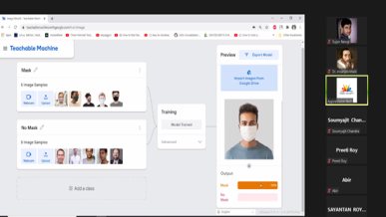
2 | ECE in collaboration with IEI Student Chapter | Online Workshop on “Value of IPR in Modern Research” | Intra College | 05.01.2021 | 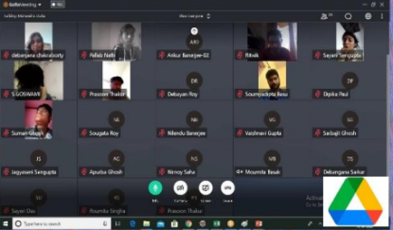
3 | ECE in collaboration with IEI Student Chapter | Online Seminar on “Transformation of Engineer to Entrepreneur -A Global Expectation” | Intra College | 20.02.2021 | 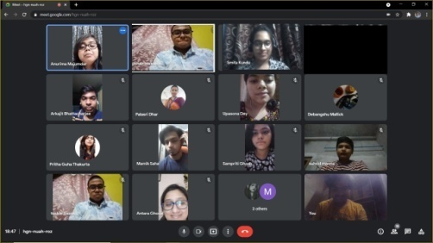
4 | ECE in collaboration with IEI Student Chapter | Online Seminar on “Block Chain” | Intra College | 23.03.2021 | 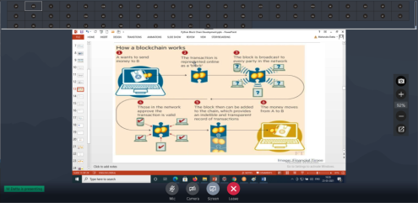
5 | ECE in collaboration with IEI Student Chapter | Seminar on “Research Methodology” | Intra College | 02.04.2021 | 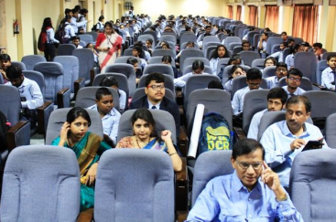
6 | ECE in collaboration with IEI Student Chapter | Online Seminar on “Python & Java Programming” | Intra College | 06.04.2021 | 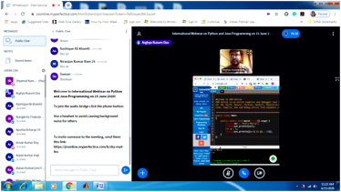
7 | ECE in collaboration with IEI Student Chapter | Online Seminar on “IPR for AI-based Innovations” | Intra College | 22.06.2021 | 