Faculty Achievement AY 2020-21

Faculty’s achievements:

      - Dr. Paramita Banerjee successfully completed NPTEL online certification on Digital Circuits in Elite + Silver category
      - Dr. Paramita Banerjee enrolled in Microprocessor and Microcontroller in NPTL course
      - Dr. Paramita Banerjee selected as a reviewer for IEEE SENSORS 202020.

      - Dr. Paramita Banerjee selected as Faculty with highest number of publication- Only Indexed Journal will be considered at JIS Samman-2021
      - Dr. Paramita Banerjee selected as MOOC Course Developer: Subject Matter Expert Group (SMEG) of Nikhil Bharat Council for Massive Open Online Course. Objective: NBC-MOOC Free of Cost Training for Students for Socio - Economic Development.

      - Bapita Roy acted as the Coordinator of IIRS/ ISRO outreach network being the representative of GNIT (Network Institute of IIRS) and participate in the conduction of the Course ‘Satellite Photogrammetry and its application” from 29th June to 5th July 2020. Two students under her mentorship qualified this course with a good marks in all India basis.

      - Bapita Roy acted as the Coordinator of IIRS/ ISRO outreach network being the representative of GNIT ( Network Institute of IIRS) and participate in the conduction of the Course RS and GIS application" from 5th to 9th Nov 2020
      - Bapita Roy completed NPTEL Course on “Introduction to Internet of Things”
      - Bapita Roy is selected as Faculty with highest no. of Students Publication from department at JIS Samman-2021
      - Bapita Roy is selected as Best Video Lectures from Department at JIS Samman-2021
      - Bapita Roy is selected as MOOC Course Developer: Member of Subject Matter Expert Group(SMEG) of Nikhil Bharat Council for Massive Open Online Course.
      - Program Designed:: Industrial Instrumentation: Pressure & Flow measurement
      - Bapita Roy is awarded Kriti 2021 for:
      - the AICTE-AQIS grant for STTP (four phases) on “Green IoT for Green Environment”
      - Acted as the Coordinator of IIRS/ ISRO outreach network being the representative of GNIT ( Network Institute of IIRS) and participate in the conduction of the Course ‘Satellite Photogrammetry and its application”. Two students under her mentorship qualified this course with a good marks in all India basis.
      - Completed NPTEL Course on “Introduction to Internet of Things” with Elite
      - Published Patent “Agro photovoltaic system (APV) – A promising solution of land Employment along with the Renewable Energy provided by the Agricultural Division” published
      - Dr. Adhish Kr. Chakrabarty is selected as a reviewer by International Journal of Robust and Nonlinear Control (an SCI-indexed journal published by Willy )

      - Dr. Adhish Kr. Chakrabarty is selected as faculty with maximum no. of Patents from the Institute at JIS Samman-2021

      - Dr. Adhish Kr. Chakrabarty is selected as Best Video Lectures from Department at JIS Samman-2021
      - Dr. Adhish Kr. Chakrabarty is awarded Kriti 2021 for:
      - Patent “Dual Condenser Distillation System” granted
      - Selected as a reviewer by International Journal of Robust and Nonlinear Control (an SCI-indexed journal published by Willy )
- Suparna Maity is enrolled for PhD program in the department of Electronics & Instrumentation Engineering at National Institute of Technology, Silchar
- Suparna Maity is MOOC Course Developer: Member of Subject Matter Expert Group(SMEG) of Nikhil Bharat Council for Massive Open Online Course.
- Program Designed: Essentials of Process Control Part 1
- Suparna Maity is awarded Kriti 2021 for:
- Published Patent on “System Identification and Modelling Approach to Identify Diseases using EMG signal Classification” published
- Completed NPTEL Course on “Introduction to Internet of Things” with Elite

- Santana Das is MOOC Course Developer: Subject Matter Expert Group(SMEG) of Nikhil Bharat Council for Massive Open Online Course. Objective: NBC-MOOC Free of Cost Training for Students for Socio - Economic Development.
- Program Designed: Essentials of Control System: Part1
- Santana Das is awarded Kriti by GNIT for the extensive effort as the OIC under MAKAUT
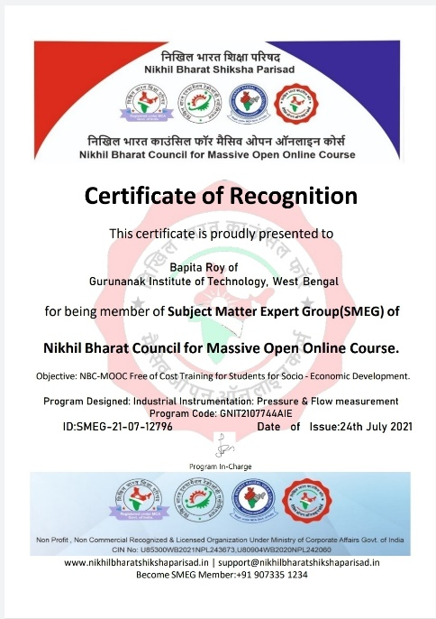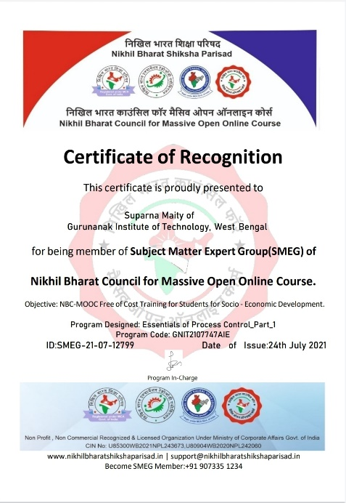

10.Departmental events (for e.g., Industry visit, Industry mentor meet, BOS meeting pic, seminar, conference work, PTM, sports, wall magazine, newsletter and others):

(a)Organized:
- A Webinar on "Upskilling / reskilling - strategy to sustain competitiveness in digital economy" organized by AEIE Department on 15TH July, 2020 where Mr. Anirban Majumder, Executive Director, Price Water house Cooopers delivered lecture. 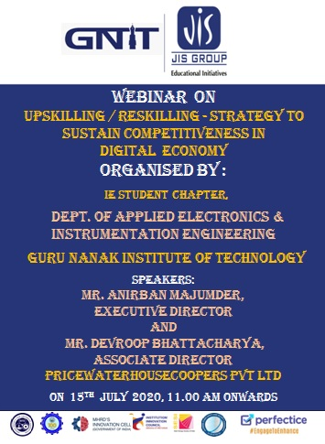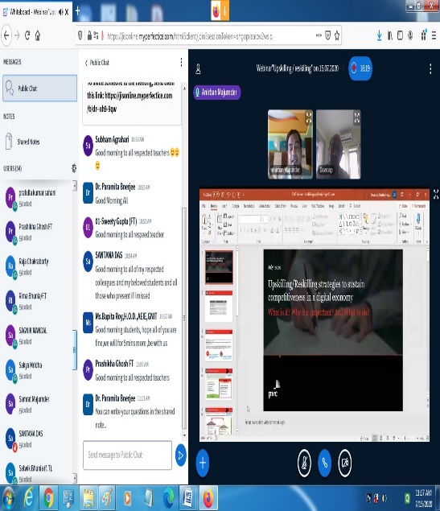

- A Webinar on " Application of Remote Control and Telemetry in Instrumentation Engineering" organized by AEIE Department on 30.08.2020 where Mrs. Bapita Roy, HOD, AEIE dept. delivered lecture.
- A Webinar on " SCADA and OCS " organized by AEIE Department on 1st September, 2020 where Dr. Adhish Kumar Chakrabarty , Assistant Professor, AEIE, GNIT delivered lecture.
- A Webinar on " Elementary Concept of the design Approach of control System
" organized by AEIE Department on 2nd September, 2020 where Mrs. Santana Das, ,Assistant Professor, AEIE, GNIT delivered lecture.
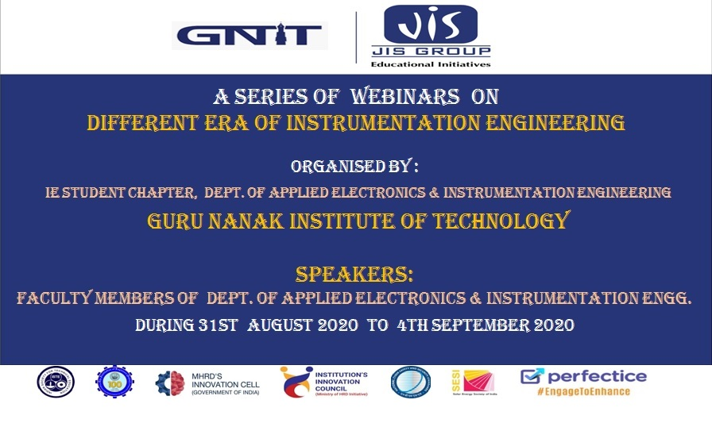
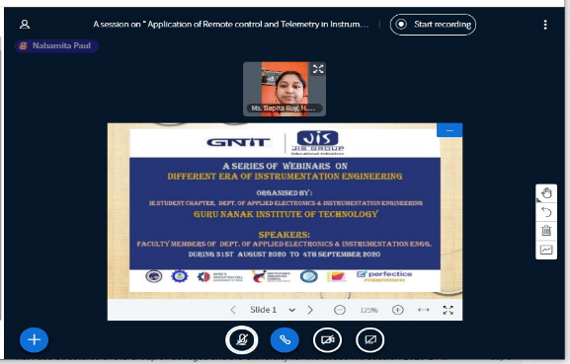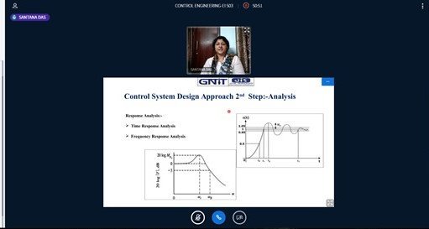

- A Webinar on "Different Measurement Systems in Instrumentation " organized by AEIE Department on 3rd September where Dr. Paramita Banerjee, Assistant Professor, AEIE, GNIT delivered lecture.
- A Webinar on " Circuit Theory-An Elemental Part of Instrumentation Engineering
" organized by AEIE Department on 3rd September ,2020 where Mrs. Suparna Maity, Assistant Professor, AEIE, GNIT delivered lecture.
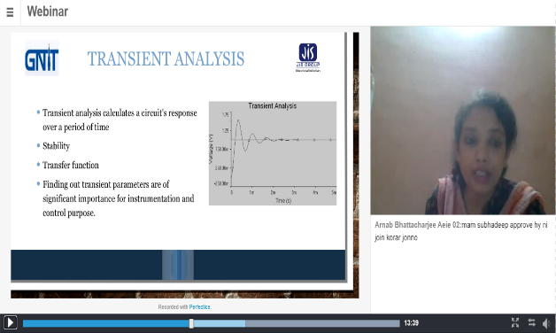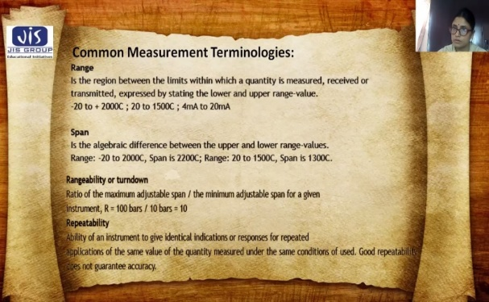

- A Webinar on " Road to Better Employability" organised by AEIE dept, GNIT " organized by AEIE Department on 12th december, 2020 where Dr. Adhish Kumar Chakrabarty , Assistant Professor, AEIE, GNIT delivered lecture.
- An Alumni Talk on “Sonomyography: Restoring Human Movement Through Sound” organised by AEIE dept, GNIT " organized by AEIE Department on 12th September ,2020 where Dr. Biswarup Mukherjee, Assistant Professor, ,Centre for Biomedical Engineering, IIT Delhi, Department of Biomedical Engineering, and AlIMS Delhi
delivered lecture

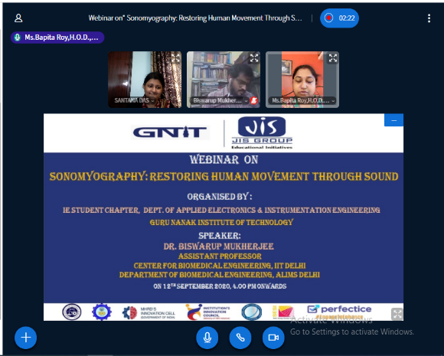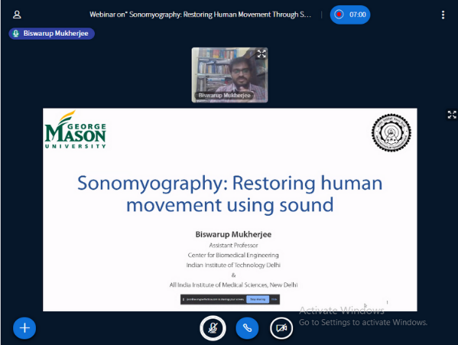

- An Alumni Talk on “Motivational speech ” organized by AEIE Department on 21st November ,2020 where Mr. Bikash Dutta , Tech Mahindra, Senior Software Engineer delivered lecture
- An Online training & Admission Drive program on “Practical Hands - on in Automation, IoT and Sensor Applications through Virtual lab experiments “, organized by AEIE Department on 16th October ,2020

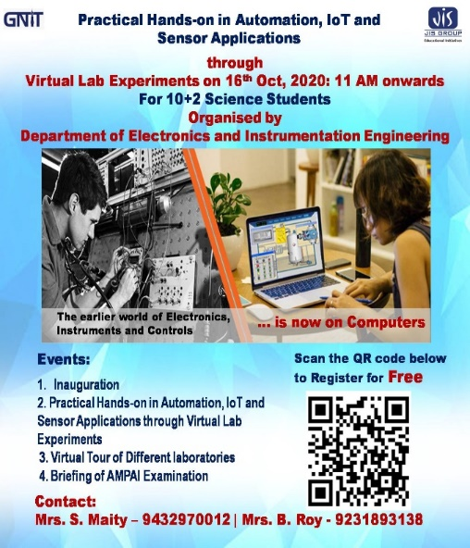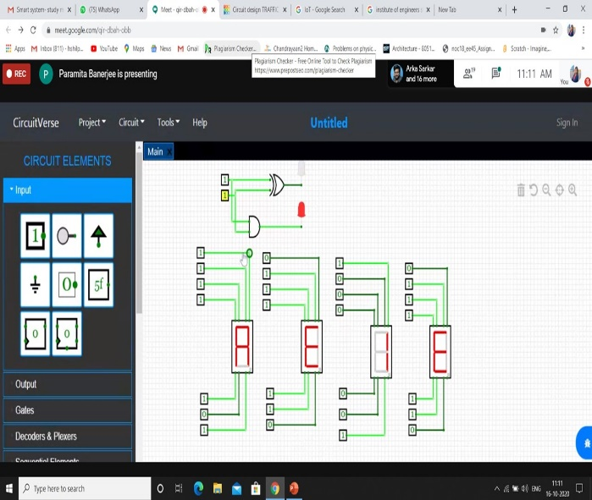

- An Online Staff Development Prog on MATLAB and Simulink, organized by AEIE Department on 23rd Nov 2020 & 3rd Dec 2020 .
- A FDP on Python & IoT, organized by AEIE & CA department from 14th to 18th December 2020 where faculty Develop Program will impart the knowledge on Python and IoT and they will be acquainted with the present industry

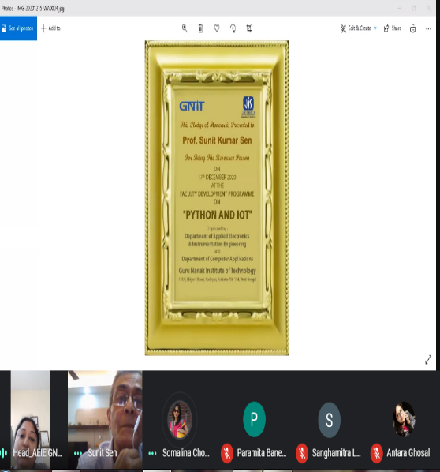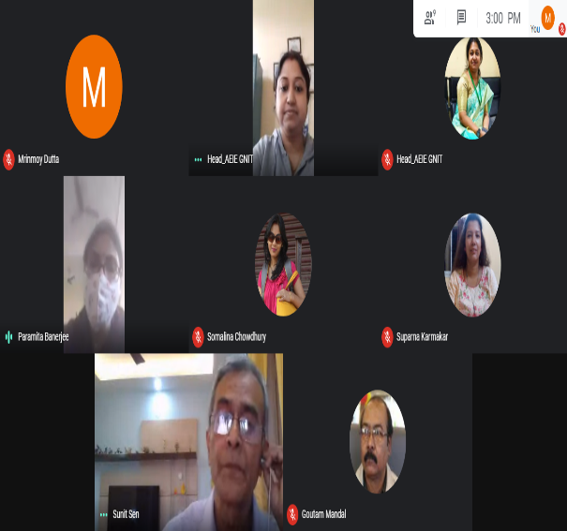.

- An Online Inter College Technical Model Competetion, organized by AEIE Department on 16th October ,2020 from 17th to 22nd February ,2021

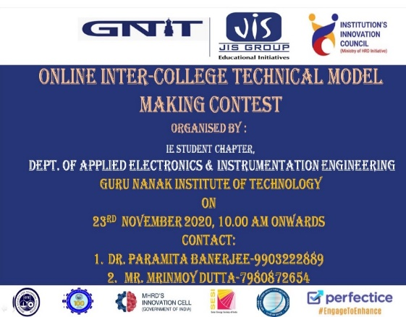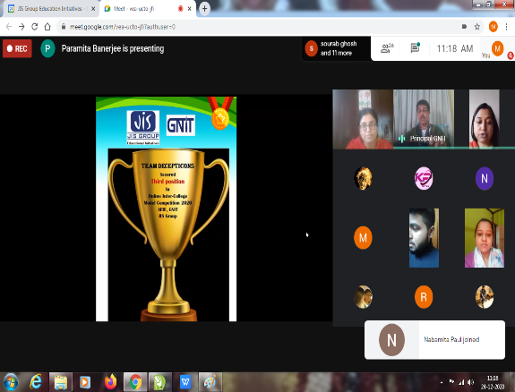

- An Intra-college Debate Competition, organized by AEIE Department on 12th March ,2021 from 17th to 22nd February ,2021

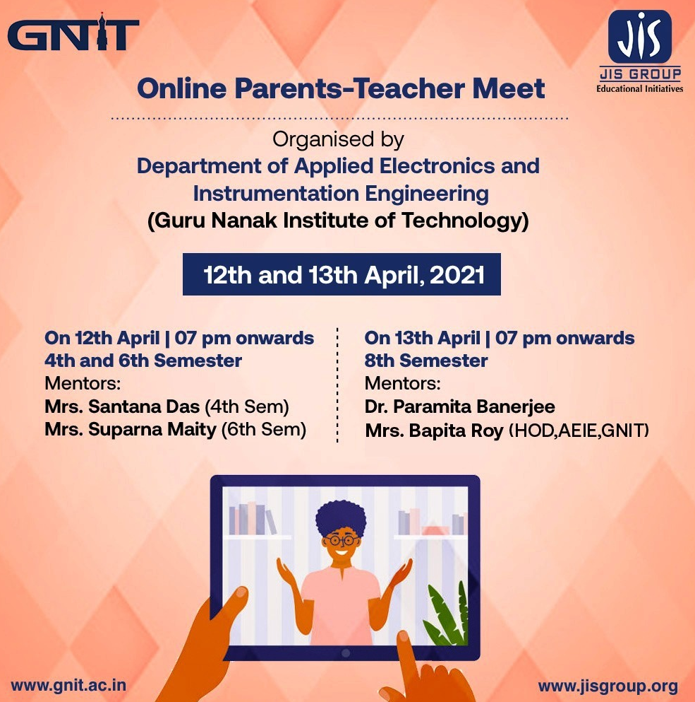

- An Online Mock technical aptitude Test , , organized by AEIE Department on8th April ,2021
for final year students of AEIE
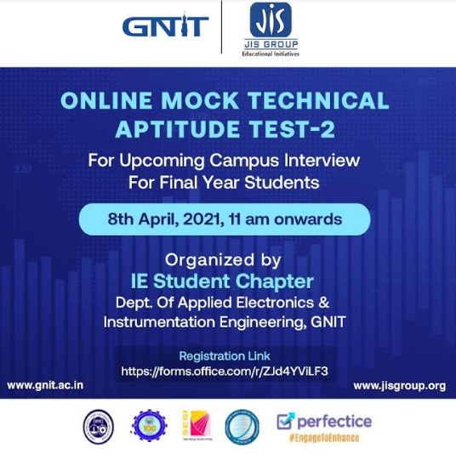

- A Hands on Training on Circuit Simulation organized by AEIE Department on21st May & 22nd May ,2021

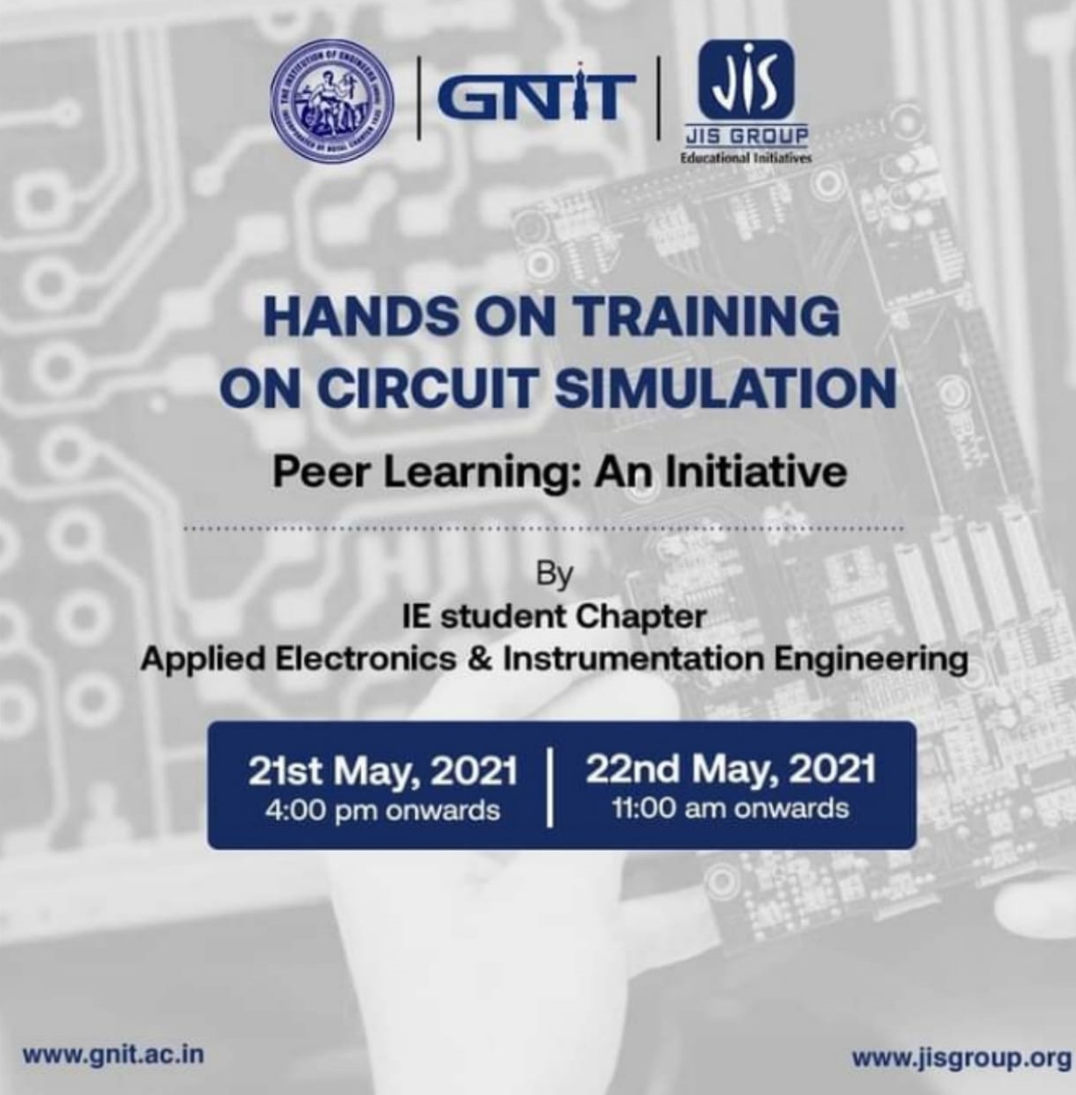

- An Online Newsletters: “AEIE Shines” organized by AEIE Department for July to December 2020
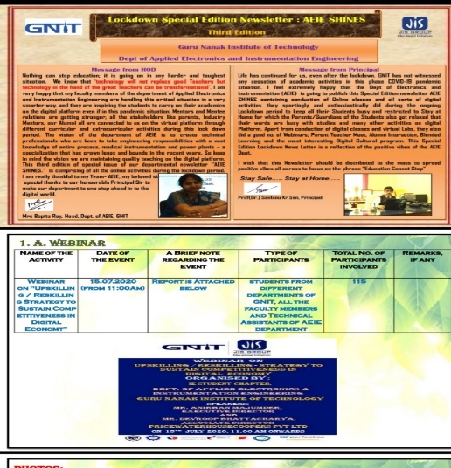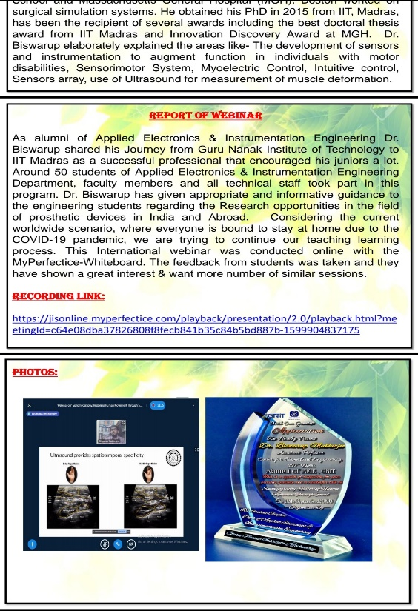
- A webinar on “Robotics for Better Life” organized by AEIE Department on 18.06.2021(Admission Drive Program)

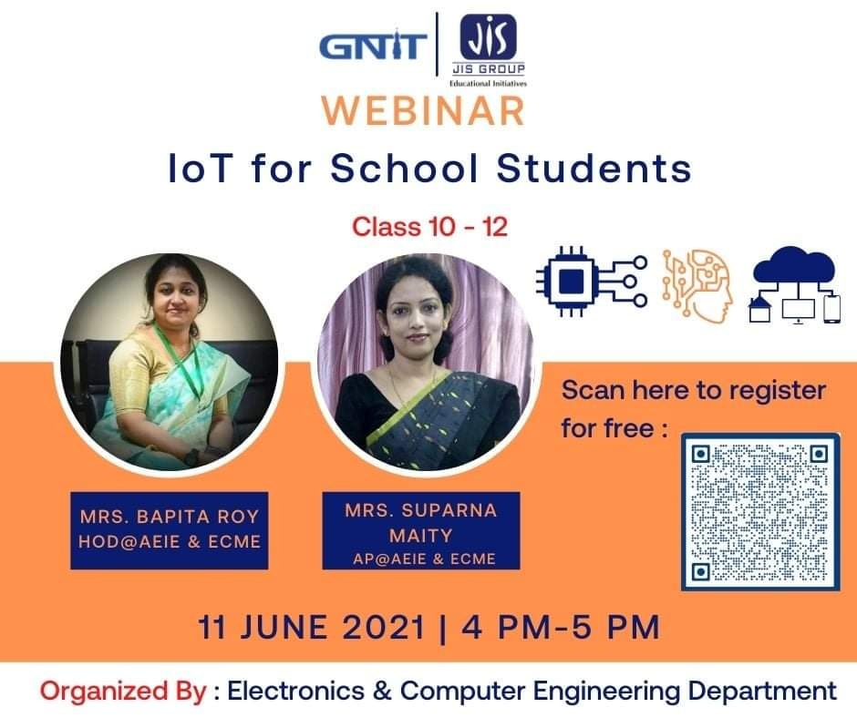

- A webinar on IoT for School Students organized by AEIE Department 0n 11.06.2021(Admission Drive Program)
- International Webinar On “Way To Start Entrepreneurship Journey & Find vc Funding Opportunity For Early Stage Entrepreneurs where Dr. Biswarup Ghosh
, Senior Research Investigator at University of Pennsylvania in Philadelphia, Adjunct Professor at Thomas Jefferson University East Falls Campus deliver lecture on 19 th June,2021

b. Seminar/workshop Participated:
i) faculty :
- Ms. Bapita Roy attended webinar on Upskilling / reskilling - strategy to sustain competitiveness in digital economy on 15.7.20, organized by GNIT
- Ms. Bapita Roy attended Webinar on “What may be the Best Assessment Approach for Higher Education Institutions - Online or Offline?" on 30.7.20, organized by ASSOCHAM INDIA
- Ms. Bapita Roy attended webinar on "Webinar on Dynamic Shift in Dissemination of Education for the future” on 30.7.20, organized by ABP Education
- Ms. Bapita Roy attended Webinar on “Webinar on “Machine Learning and Steganography"
" On 04-08-2020, organized by Department of Computer Science and BCA, Kharagpur College
- Ms. Bapita Roy attended webinar on "Importance of Electrical Energy Audit Confirmation" on 24-08-2020, organized by Hoiki India Pvt.Ltd
- Ms. Bapita Roy attended Webinar on "Tomorrow’s Tech for Tomorrow’s Careers: Big Data, AI, iOT and ML" on 01.09.20, organized by ABP education
- Ms. Bapita Roy attended webinar on" Western Region Presents Techno-Intelligence e-Conclave 2020 Confirmation" by ASSOCHAM 0n 10.9.21
- Ms. Bapita Roy attended Webinar-based workshop on "Increase the employability of graduates" organised by AICTE on 5.11.21
- Ms. Bapita Roy attended Webinar on " The art of creating instructional videos" on 6.11.20 by JIS group
- Ms. Bapita Roy attended webinar on “AI Transformation in Higher Education: Significance of Personalized Learning” on 10.11.20 by ASSOCHAM
- Ms. Bapita Roy attended One Week Online Workshop on "Intellectual Property Rights and Entrepreneurship Development (IPRED-2020)" organized by NIT Silchar from 1.9.20.to 5.9.20
- Ms. Bapita Roy attended webinar on Introduction to Inner Engineering on 29.12.20, organized by Isha Foundation in collaboration with GNIT
- Ms. Bapita Roy attended Workshop on Entrepreneurship Development Phases in the Next Normal on 9.12.20 organized by FT department, GNIT
- Ms. Bapita Roy attended webinar on "AI Transformation in Higher Education: Role of Faculty in Institutionalizing AI Technology on 20.01.21, organized by ASSOCHAM
- Dr. Paramita Banerjee attended webinar on Upskilling / reskilling - strategy to sustain competitiveness in digital economy on 15.7.20, organized by GNIT
- Dr. Paramita Banerjee attended Webinar on “What may be the Best Assessment Approach for Higher Education Institutions - Online or Offline?" on 30.7.20, organized by ASSOCHAM INDIA
- Dr. Paramita Banerjee attended webinar on "Webinar on Dynamic Shift in Dissemination of Education for the future” on 30.7.20, organized by ABP Education
- Dr. Paramita Banerjee attended Webinar on “Webinar on “Machine Learning and Steganography" on 04-08-2020, organized by Department of Computer Science and BCA, Kharagpur College
- Dr. Paramita Banerjee attended webinar on "Importance of Electrical Energy Audit Confirmation" on 24-08-2020, organized by Hoiki India Pvt.Ltd
- Dr. Paramita Banerjee attended webinar on " Webinar on Hioki Test Solution for Green Energy"
" on 27-08-2020, organized by Hoiki India Pvt.Ltd
- Dr. Paramita Banerjee attended webinar on " "Local Drug delivery to the Injured Cervical Spinal Cord using Engineered Hydrogel Preserves Diaphragm Function"" on 27-08-2020, organized by Hoiki India Pvt.Ltd
- Dr. Paramita Banerjee attended Webinar on Investors Protection, Education & Awareness - The Way Forward” on 8-09-2020, organized by ABP Education

- Dr. Paramita Banerjee attended AICTE-AQIS- STTP Phase 1 on “Gren IOT for Green Environent” from 19.4.21 to 24.4.21, organized by AICTE-AQIS

- Dr. Paramita Banerjee attended webinar on "Importance of Electrical Energy Audit Confirmation" on 24-08-2020, organized by Hoiki India Pvt.Ltd
- Ms. Santana Das attended webinar on Looking to the Future of Passive Components organized by KEMET COMMUNICATION, USA on 01-07-2020
- Ms. Santana Das attended webinar on “3 years of GST: Key open legal issues & points arising out of the COVID scenario” on 02-07-2020, organized by ASSOCHAM, INDIA
- Ms. Santana Das attended webinar on "Designing In Passives for Uninterruptible Power Supplies" organized by KEMET COMMUNICATION, USA on 06-07-2020
- Ms. Santana Das attended webinar on "Quest for Ph.D. - Research Matter" on 13-07-2020, organized byAlumni Association in collaboration with IIC - GNIT & MHRD
- Ms. Santana Das attended webinar on Power Conversion from AC Mains to Device - organized by KEMET COMMUNICATION, USA on 13-07-2020
- Ms. Santana Das attended Digital Transformation of Higher Education & preparing students for future job skills on15-07-2020
- Ms. Santana Das attended Leadership talk of Dr. Abhay Jere,MHRD,AICTE with Shri Anand Mahindra, Chairman Mahindra group on 18-07-2020 organized by MHRD,AICTE
- Ms. Santana Das attended the webinar on the topic Atmanirbhar Bharat – Role of Higher Education Institutions on 20-07-2020 organized by ASSOCHAM
- Ms. Santana Das attended webinar on SELF RELIANCE AND NATIONAL SECURITY EMERGING IMPERATIVE on 22-07-2020 organized by Institute of Engineers
- Ms. Santana Das attended Leadership talk of Dr.Abhay jere , chief Executive officer , IIC,MHRD with Leadership Talk with Ms. Shradha Sharma, Founder and CEO YourStory Media on 25-07-2020 organized by IIC,MHRD
- Ms. Santana Das attended the webinar on "Webinar on Annual Pump Performance Test for Fire Pumps" on 04-08-2020 organized by ASSOCHAM
- Ms. Santana Das attended the MOLECULAR BIOLOGY WEBINAR: Molecular basis of regulation of transcription by second messenger ppGpp on 06-08-2020 organized by Sathyabama Institute of Science and Technology, Chennai
- Ms. Santana Das attended the webinar on Illness to Wellness- Building Immunity Through Nutritious Food During COVID 19 on07-08-2020 organized by ASSOCHAM, INDIA
- Ms. Santana Das attended webinar on MINDISK - Let's PROGRAM a peaceful mind on 08-08-2020 organized by Techno India Education
- Ms. Santana Das attended the webinar on- "Online Education: Is an e-learning degree as valuable as a traditional degree?" on 17-08-2020 organized by ABP Education
- Ms. Santana Das attended webinar on the topic Computer Science, Computer Applications and IT organized by ABP Education on 19-08-2020 organized by ABP Education
- Ms. Santana Das attended Drones in Mineral Exploration: Analyzing its applications and integration” on24-08-2020 organized by ASSOCHAM, India
- Ms. Santana Das attended How Technology is Changing Careers in Finance: Fintech, Block chain and more on 25-08-2020 organized by ABP Education
- Ms. Santana Das attended Online National Summit HOUSING FOR ALL -AFFORDABLE AND RENTAL HOUSING: THE WAY FORWARD on 26-08-2020 organized by ASSOCHAM, India
- Ms. Santana Das attended "New Education Policy 2020 - Knowledge Series Transforming Higher Education: Structure and Processes" on 27-08-2020 organized by ASSOCHAM, India
- Ms. Santana Das attended National Vice Chancellors' Round Table: Three Emerging Careers starts 0n 28-08-2020 organized by ABP Education
- Ms. Santana Das attended Low power VLSI on 29-08-2020 organized by K.S.R College of Engineering,Tiruchengode
- Ms. Santana Das attended "sonomyography: Restoring Human Movement Through Sound " on
12-09-2020 organized by AEIE, GNIT
- Ms. Santana Das attended Moving towards a Green and Sustainable Nation, on 19-09-2020 organized by ASSOCHAM, INDIA
- Ms. Santana Das attended webinar on "Engineering Business Incubation & Entrepreneurship" on
organized by National Skill Development Forum of IEI
- Ms. Santana Das attended webinar on "The Art of Creating Instructional Videos" on 06-11-2020
organized by JIS group
- Ms. Santana Das attended webinar on Designing Drug for Coronavirus on 12-11-2020
- Ms. Suparna Maity attended Webinar on "Tomorrow’s Tech for Tomorrow’s Careers: Big Data, AI, iOT and ML" on 01.09.20 organized by ABP education
- Ms. Suparna Maity attended webinar on" Western Region Presents Techno-Intelligence e-Conclave 2020 Confirmation" by ASSOCHAM on 10.09.20 organized by ASSOCHAM
- Ms. Suparna Maity attended webinar -based workshop on "Increase the employability of graduates" organised by AICTE on 05.11.20
- Ms. Suparna Maity attended webinar on " The art of creating instructional videos" on 06.11.20
- organised by JIS Group
- Ms. Suparna Maity attended webinar on “AI Transformation in Higher Education: Significance of Personalized Learning” on 10.11.20 organised by ASSOCHAM
- Ms. Suparna Maity attended One Week Online Workshop on "Intellectual Property Rights and Entrepreneurship Development (IPRED-2020)" organized by NIT Silchar from 01.09.20 to 05.09.20
- Ms. Suparna Maity attended webinar on Introduction to Inner Engineering on 29.12.20 organised by Isha Foundation in collaboration with GNIT
- Ms. Suparna Maity attended webinar on "Road to Better Employability" organised by AEIE dept, GNIT on 12.12.20
- Ms. Suparna Maity attended Workshop on Entrepreneurship Development Phases in the Next Normal on 9.12.20 organized by FT department,GNIT
- Ms. Suparna Maity attended webinar on "AI Transformation in Higher Education: Role of Faculty in Institutionalising AI Technology on 20.01.21 organized by ASSOCHAM

- Ms. Suparna Maity attended AICTE-ISTE sponsored refresher program on “Engineering Applications of Optimization” organised by Department of Automobile Engineering,Rajiv Gandhi Govt. Polytechnic,Department of Education,Itanagar-791113, Arunachal Pradesh from 05.04.21 to 10.04.21 organized by AICTE-ISTE
- Ms. Suparna Maity attended AICTE-AQIS- STTP Phase 1 on “Gren IOT for Green Environent”
From 19.04.2021 to 24.04.2021 organized byAICTE-AQIS

- Technical staff: Ms. Saswati Chatterjee, Ms. Nabamita Paul & Mr. Mrinmoy Dutta :
- attended a Webinar on IoT its applications on 07/07/20 organized by
CSE GNIT
- attended a webinar on "Upskilling / reskilling - strategy to sustain competitiveness in digital economy" on 15/07/20 organized by AEIE Department.
- attended a webinar on Aatmanirbhar Bharat Role of Higher Education Institutions on 20/07/20 organized by ASSOCHAM India
- attended a Webinar on"SELF RELIANCE AND NATIONAL SECURITY EMERGING IMPERATIVES" on 22/07/20 organized by IEI HQ
- attended a Webinar by Dr. Abhijit Chowdhury on COVID 19 On 05/08/20 organized by JIS group
- attended a Webinar on “The Current Global Crisis & Food Safety” On 07/08/20 cMitra SK Pvt. Ltd.
- attended a FDP: Tracing the contours of new normal :Post Covid -19 From 11/08/20 to 16/08/20 organized by ASHU,FT&BHM
- attended a Webinar on”Bengal Education Leaders’ Summit with education minister Partha Chatterjee: Is Higher Education in Bengal today geared for Careers of Tomorrow?” On 12/08/20 organized by ABP Education
- attended a Webinar on Hioki test solution for Green Energy on 16.08.2020 organized by Hioki test solution
- attended a webinar on the ‘National Education Policy 2020’on 17.08.2020 organized by FICCI
- attended a Webinar on Data Science and Artificial Intelligence: Revolutions for Present and Future on 22.08.2020 organized by The Neotia University (TNU), Kolkata
- attended a webinar on Role of Private Equity during Pandemic: Challenges & Opportunities starts in 1 Hour on 25/08/20 organized by ASSOCHAM INDIA
- attended a International Webinar on "Local Drug delivery to the Injured Cervical Spinal Cord using Engineered Hydrogel Preserves Diaphragm Function" on 27/08/20 organized by AEIE Department
- attended a Webinar on e-counselling on 27/08/20 organized by ABP education
- attended a Webinar: "Energy Performance Contracting (EPC): India's Economy Booster Post COVID19" on 28/08/20 organized by ASSOCHAM India
- attended a AICTE Sponsored Short Term Training Programme (Phase-II) on "Recent Trends in Internet of Things (IoT) and Embedded System Based Monitoring and Control of Distributed Generation." from 24/08/20 to 29/09/20 organized by AICTE
- attended a Webinar: Energy Audits in Mixed Use Buildings on 09/09/20 organized by HOIKI
- attended a webinar on " Sonomyography: Restoring Human Movement Through Sound” on 12/09/20 organized by AEIE Department
- attended a webinar-based workshop on ‘Employability of graduates. On 5/11/20
- attended a Webinar on “Embedded systems and Robotics” on 25/11//20
organized by AEIE Department
- Publication:

  - Faculty and staff:
International Journal: 8

  - Student:
International Journal: 1
International Conference: 8

- Result (Bar Chart):

SGPA WISE RESULT ANALYSIS (CSE) AY 2020-21

2020-21 ODD SEM:

3rd Semester:

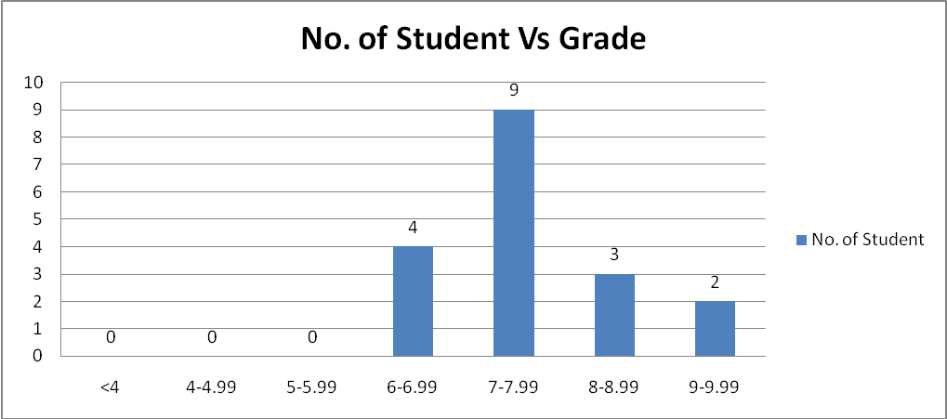

5th Semester:
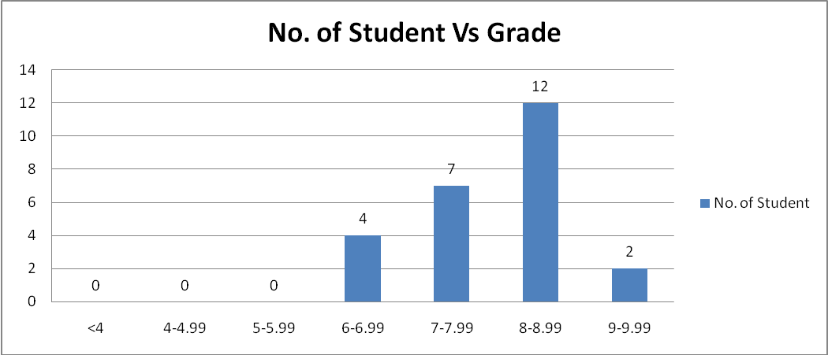

7th Semester:
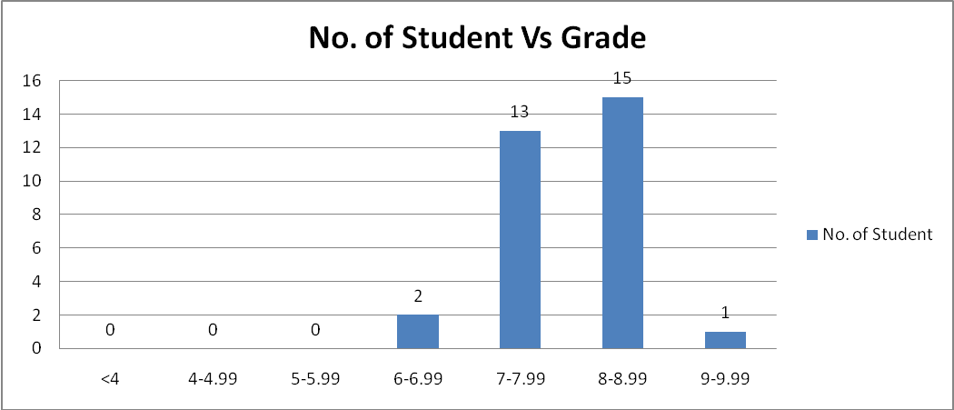

2020-21 EVEN SEM:
4th Semester:

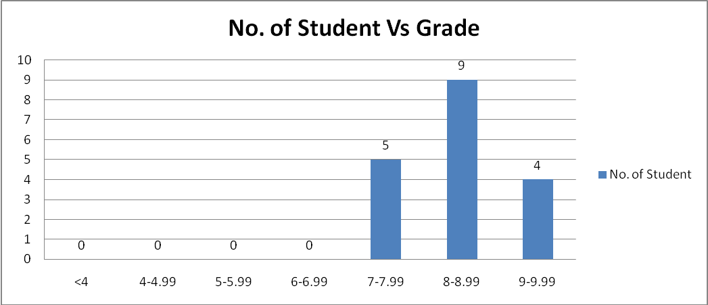

6th Semester:
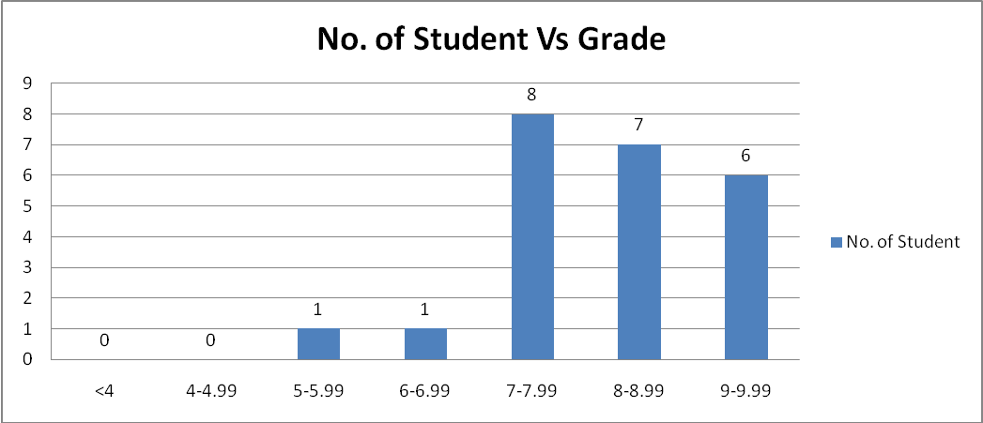

8th Semester:
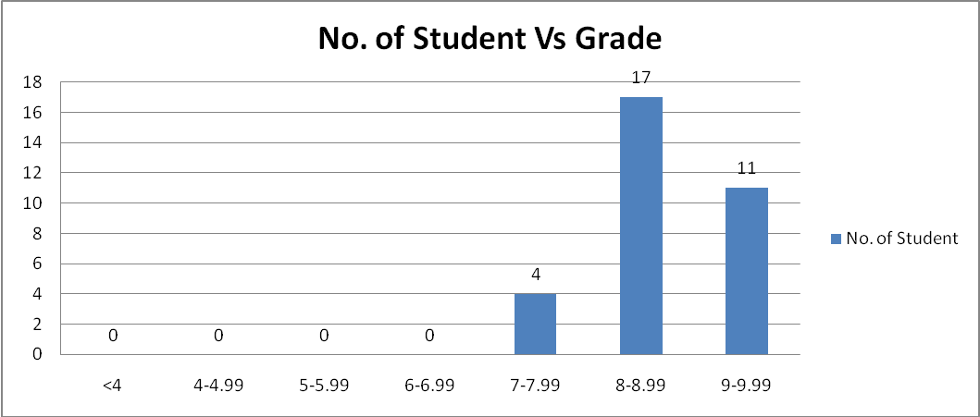

- 2020-21- Placement and higher studies (Bar chart):-

Total student | Student Placed | Higher Study | Entrepreneurship
32 | 9 | 6 | 2

